English 3.6
Create a character profile

Watch the following video:
https://www.bing.com/videos/search?q=matilda+miss+trunchball&&view=detail&mid=B0641A3F027597BF8A5DB0641A3F027597BF8A5D&&FORM=VRDGAR&ru=%2Fvideos%2Fsearch%3Fq%3Dmatilda%2Bmiss%2Btrunchball%26FORM%3DHDRSC4
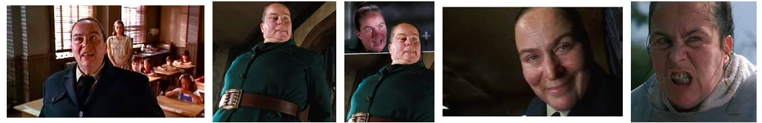

What is an adjective?
How many adjectives can you name to describe Ms Trunchbull?

Complete the activity below.

Activity
Create sentences and phrases to
describe her appearance and personality using adjectives.

Eg: Being an extremely cunning Headteacher, it’s almost impossible to pull the wool over her eyes. Her towering stature makes her students appear miniscule in her presence…

Use the following amazing adjectives to help you create your own character profile.

