12.6 Victorian Schools
Watch the following clip from ‘Horrible Histories’ https://www.bing.com/videos/search?q=Horrible+Histories+Victorian+School&&view=detail&mid=CB59E4A908C7ED4EC48ECB59E4A908C7ED4EC48E&&FORM=VRDGAR&ru=%2Fvideos%2Fsearch%3Fq%3DHorrible%2BHistories%2BVictorian%2BSchool%26FORM%3DVDMHRS
Read the following information all about Victorian schools.

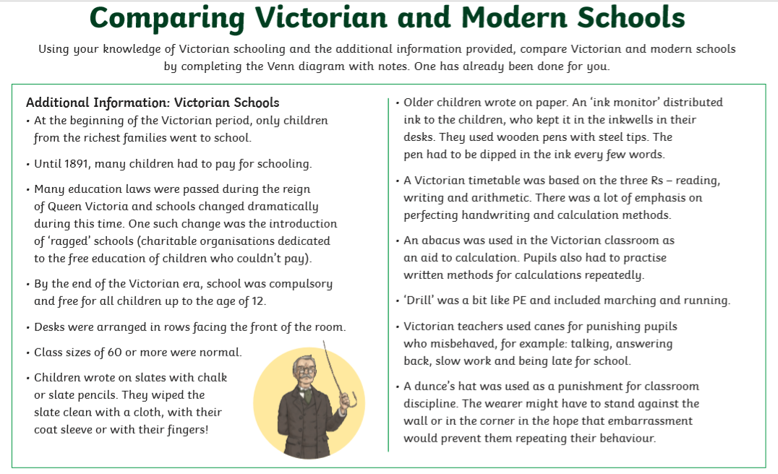
Compare Victorian and modern schools by using the information given to complete the Venn diagram.
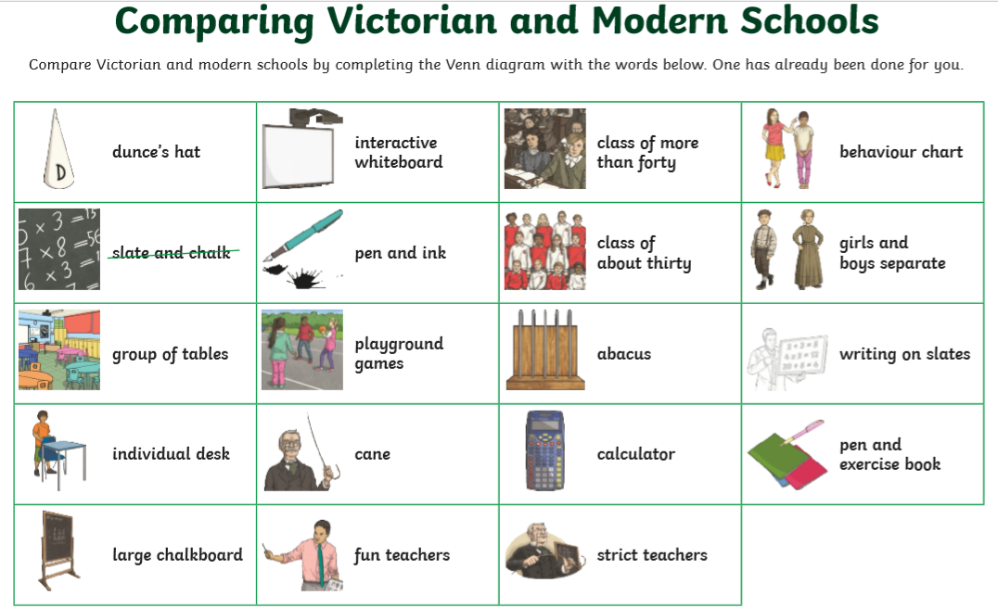
Write each of these in your own Venn diagram use the diagram below.
