History – Who were the Victorians?

Go to the following web page and learn as much about Queen Victoria as you can.
https://www.bbc.co.uk/teach/class-clips-video/ks2-queen-victoria-the-ultimate-victorian/z79vhbk
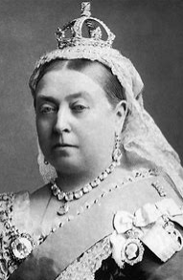

Activity 1
Use the events below to create your own timeline.
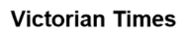
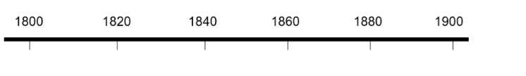
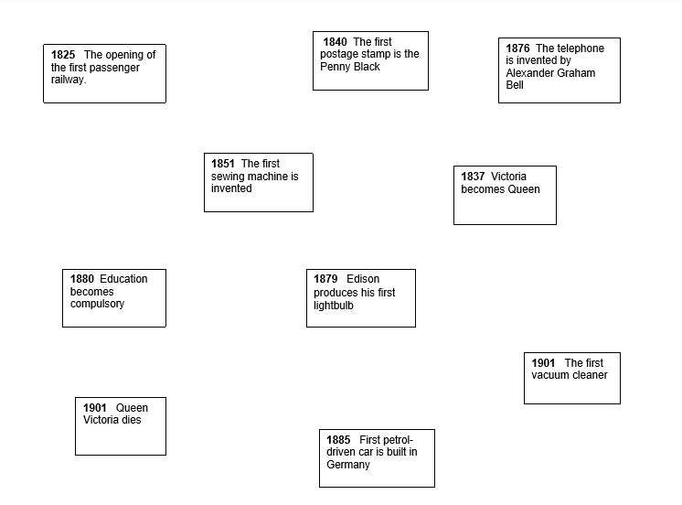
Which of these events do you think are the most important? Why?

Activity 2
Complete the fact file below. Research Queen Victoria if you are unsure. Use this website to help.
https://www.natgeokids.com/uk/discover/history/monarchy/ten-facts-about-queen-victoria/

