12.6 The Shang Dynasty

Hello Owl’s, will be studying the ancient Chinese Shang Dynasty. Find a map of China, either in an atlas or on-line. Locate the following places:

Activity 1

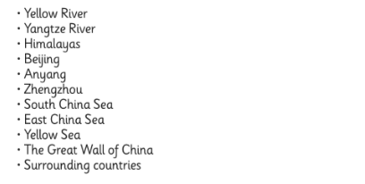

Activity 2

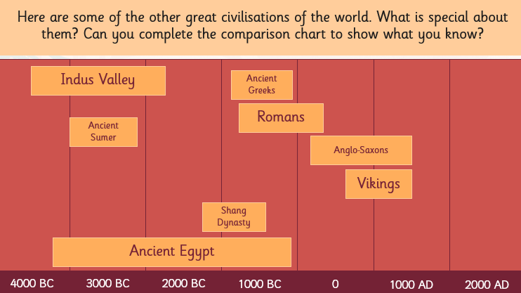

Comparison chart

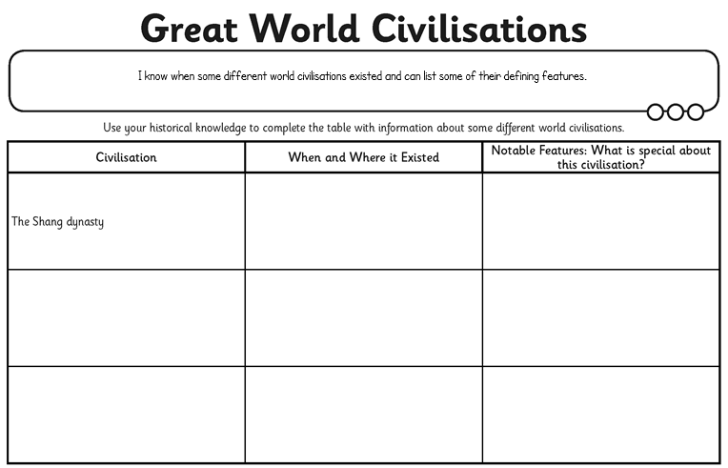

Activity 3

Order the events below into the correct chronological order and draw your own timeline.

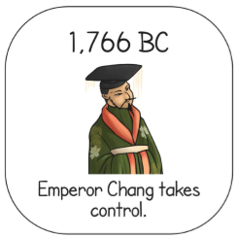 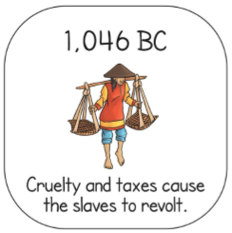

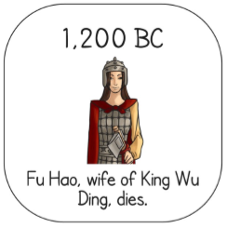 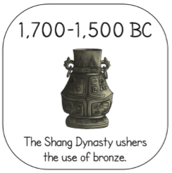

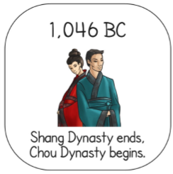 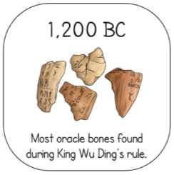

Why not do some research of your own. What can you find out?