Shang Dynasty - History and ICT
Go to the following web page – What was is like to live in the Shang Dynasty?
https://www.bbc.co.uk/bitesize/topics/z39j2hv/articles/zqtn6yc
Make a leaflet about everything you have learnt. Comment on each of the pictures below
Activity 1
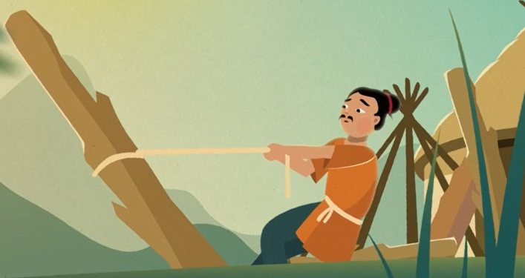 Buildings
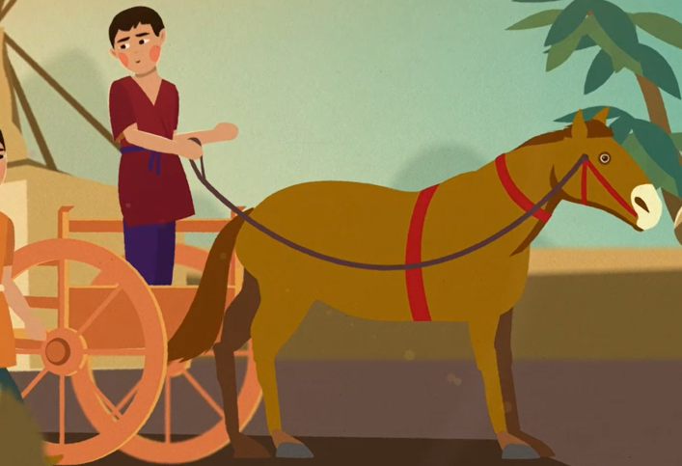 Transport
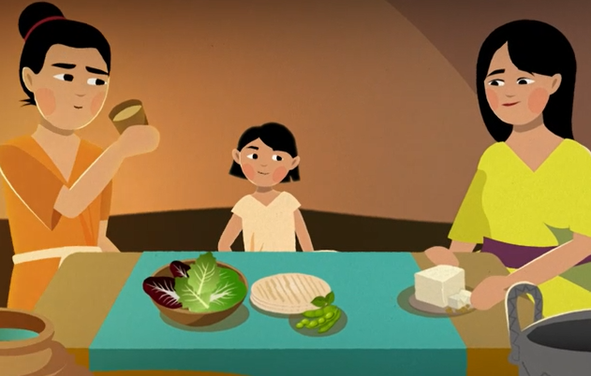 Food
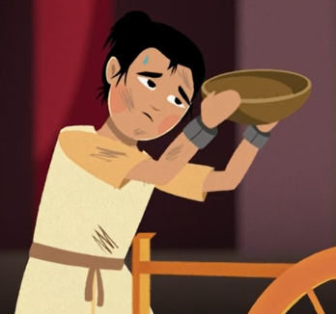

Poor people

Rich people
Activity 2 (ICT)
Choose one of these areas and do your own research about everyday life in the Shang Dynasty. Create a power point presentation to present to your classmates.

