Life Skills, Healthy Strawberry and Banana Ice Cream.
You will need a food processor or blender to get the right result!
Ingredients
Bananas
Strawberries
Method
First, slice some ripe bananas (so they’re sweet and full of flavour) and strawberries.
Arrange them in a single layer on a baking sheet tray with baking paper, and pop them in the freezer for about 2 hours.
Once they’re frozen, place the fruits in your food processor (step 3) if the fruits are stuck on the sheet, let it sit for a couple of minutes before lifting the baking paper.
Start the food processor/blender and process until it’s nice and smooth. The mixture will go through different stages: crumbly (step 4), part crumbly part smooth (step 5) and finally, smooth (step 6).
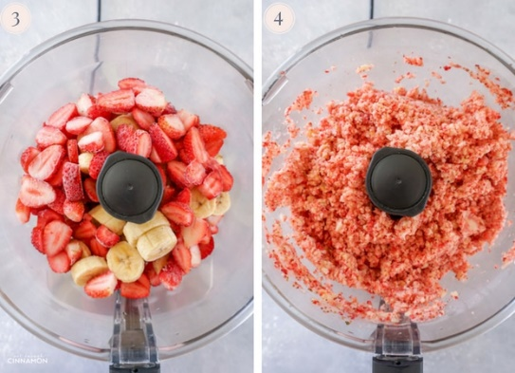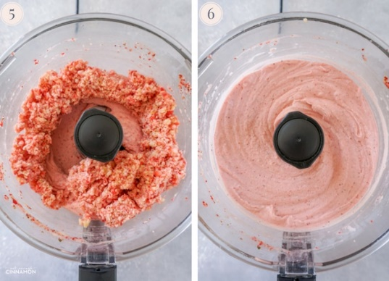
At the end, it should have a smooth, soft-serve consistency). It takes a while to reach the perfect texture – don’t worry, it’s normal. Keep pulsing until you create ice cream magic!
You can eat it straight away as a soft-serve, but if you want a firmer, more ice-cream like texture, transfer the mixture to a metal container – I used a loaf tin – and freeze for about 3 to 4 hours or until firm.
It will be hard straight out of the freezer so let it sit for 5 to 10 minutes before scooping and enjoying!

