Maths 15.6
Go to the following webpage:
https://www.bbc.co.uk/bitesize/articles/zbdwg7h
Watch the video on telling the time and try the four activities.

If you find this challenging try some of the following:
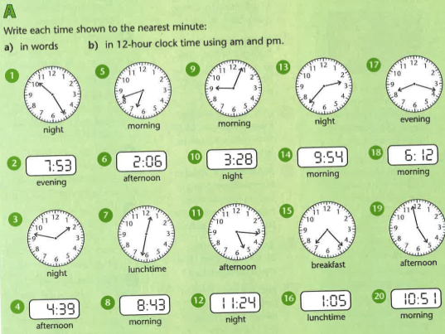
Find the answers below.

Answers
