Year 3 Maths – Multiply a 2-digit number by a 1-digit number.
- Follow this link: https://www.bbc.co.uk/bitesize/articles/zb4gcqt
- Go through ‘Learn’ and watch the videos available.
- Go through the practise.

Activity 1 – Online ‘My Maths.’
- Go through the numbers on the left and answer the questions given.
Activity 2 – Worksheet is below.
Activity 3 – Worksheet is below.

Long Multiplication help for Activity 2:
2. Look at your ‘One’s’ column.
You are going to multiply 8x3 = 24.
24 is made up of 20 and 4 or 2 tens and 4 ones.
We are going to put the 2 tens underneath the tens column and the 4 under the ones column.
Question 1:
3. Look at your ‘Tens’ column.
You are going to multiply 8x9 = 72.
72 is made up of 70 and 2 or 7 tens and 2 ones.
We are going to add the 2 tens we have underneath the tens column making 74.
We don’t have another column to multiply, so we place the 4 into the ‘tens’ column and move the 7 into the ‘hundreds’ column.

H T O
₉₃

x8

7
4
4

2

1. Look for your ‘Multiplier.'
This is the number you multiply by.

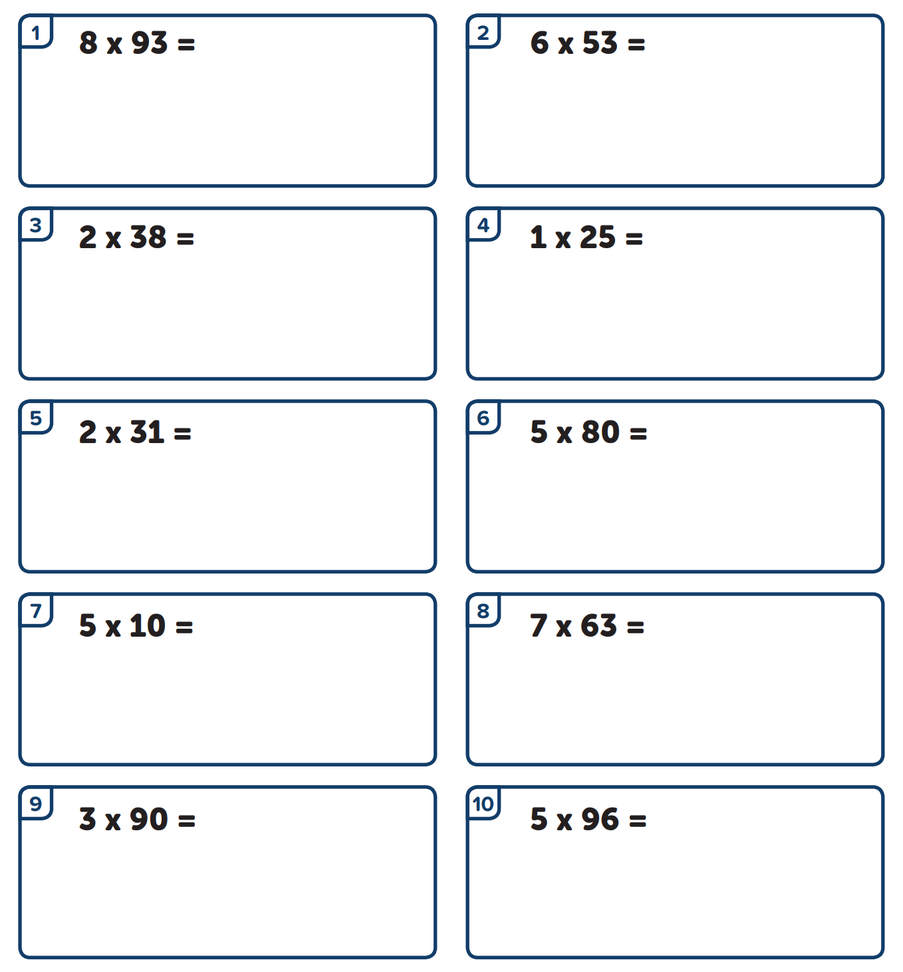
Activity 2:

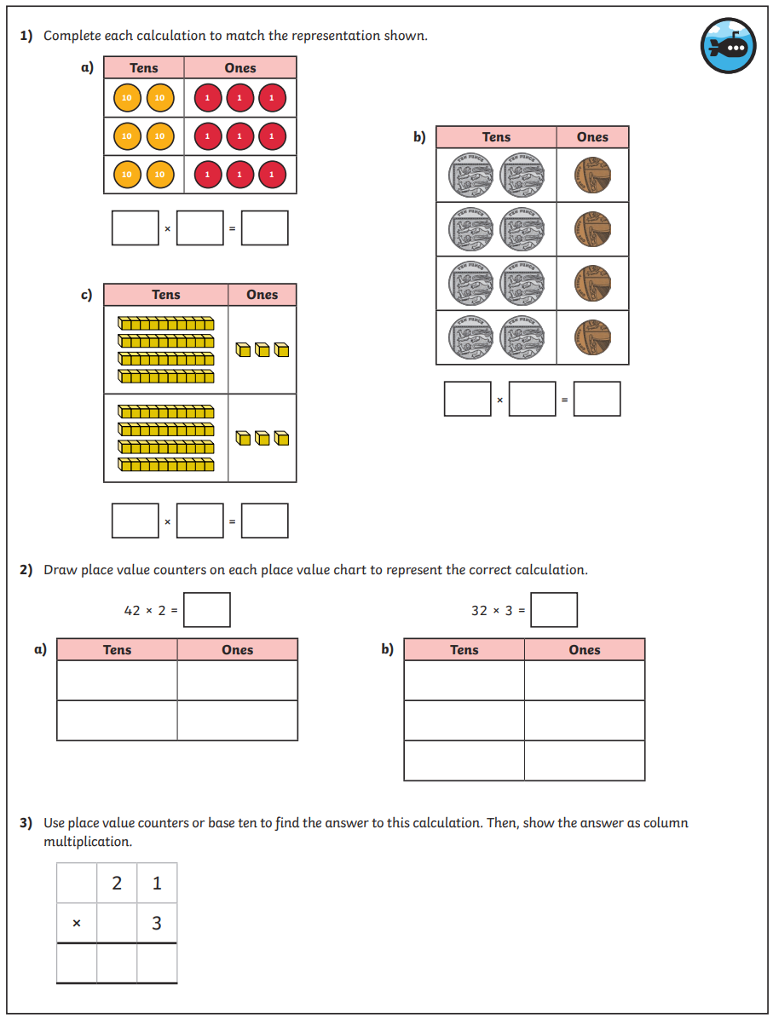
Activity 3:
