Year 3 Maths: Divide a two-digit number by a one-digit number
- Follow this link: https://www.bbc.co.uk/bitesize/articles/zbkdjhv
- Go through the ‘Learn’ section and watch the videos.
- Move onto ‘Practise’ and complete the activities.

Activity 1 – Activity is below.
Activity 2 – Activity is below.
Activity 3 – The activity is online. Work through the numbers down the sides of the page and work through the questions provided.
Challenge – This is a selection of questions using the ‘bus stop’ method. There is an example question above. Please answer these questions on scrap paper.

Activity 1:

Activity 2:
Count in 5’s until you get to 70. How many jumps have you made?
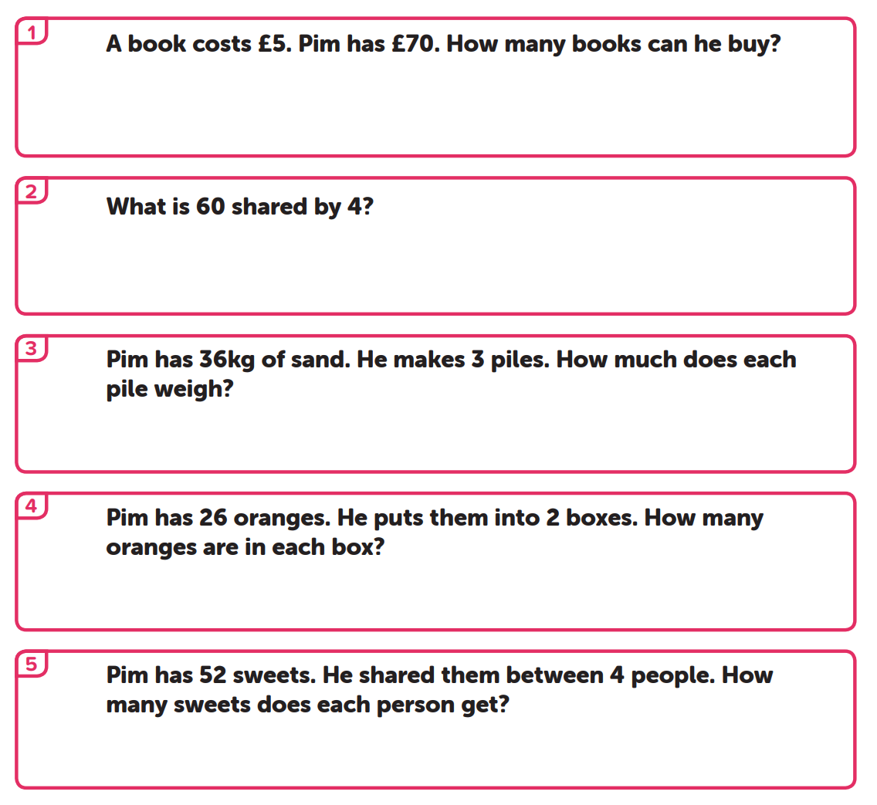
Make 4 circles. Share 52 equally between them.
Make 2 circles. Share 26 equally between them.
Make 3 piles/circles. Share 36 between them equally.
Make 4 circles and share 60 equally between them.

Challenge: Don’t be fazed by e – i. Use the same ideas as above.
Let’s do a) together.
1. Find your divider.
Your divider is 4.
T O

1
2
2. Look at your tens column. How many times does your divider (4) go into 8 tense?
Count in 4’s.
80 ÷ 4 = 20 or 2 tens.
2 tens go above the 8.
3. Now, move onto the ones.
How many times does 4 go into 4?
Count in 4’s again.
4 ÷ 4 = 1.
1 goes above 4.

Now it’s your turn:

