Year 3 and 4 Maths:
- Please follow this link: https://whiterosemaths.com/homelearning/year-4/
- Please watch the videos for ‘Lesson 3 and 4.’
- Please note that there are no worksheets following these videos so please complete the work below according to Green, Red and Blue.

Green – The first one has been done for you:
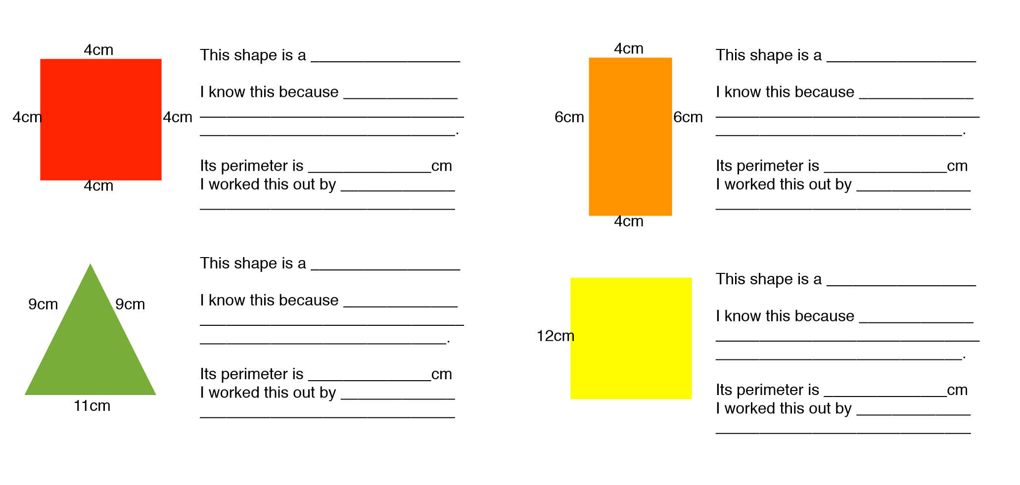
Square

It has 4 equal sides.
16cm

Adding up all the sides of the square.

Green, Red and Blue
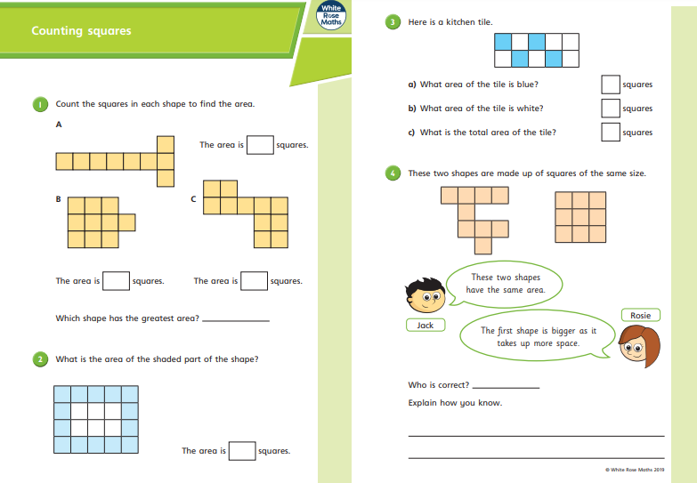

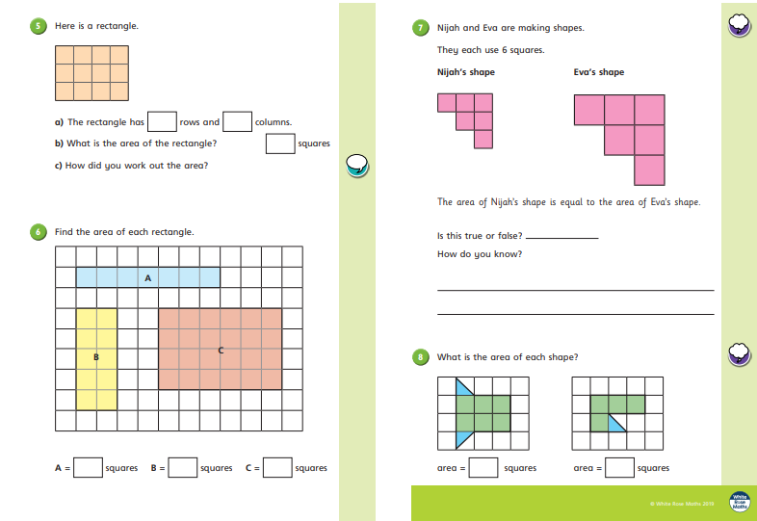

Red/Blue
