Maths Year 3 and 4
Go to the following web page: https://www.bbc.co.uk/bitesize/articles/zcxy6g8
Watch the video, try the activities and have a go at the questions below.
Year 3
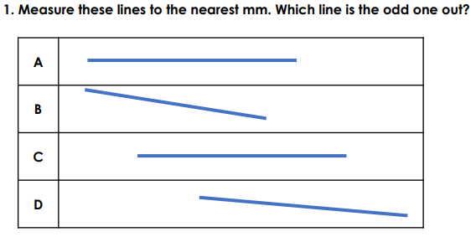
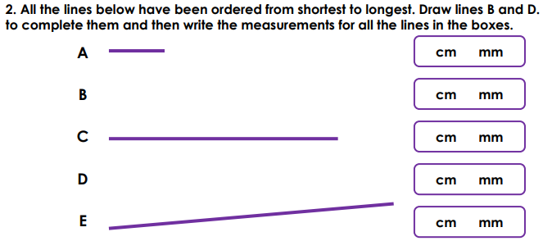
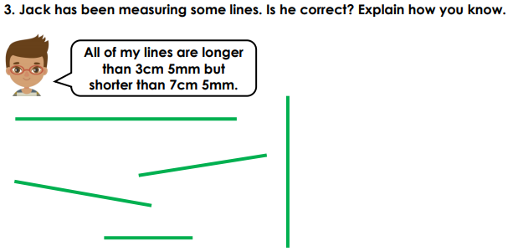

Year 4
Attempt as many of these as you can

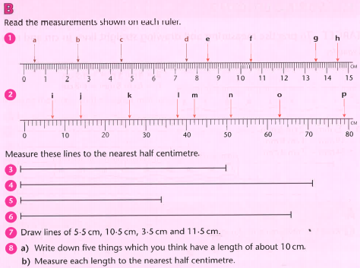

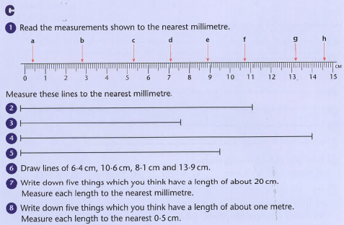

Find the answers below
Year 3
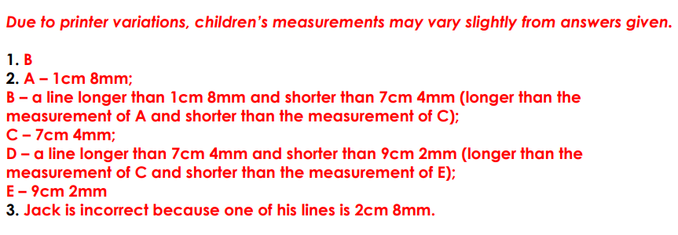

Year 4
