Year 4 Maths – Multiplication and Division Problems.
- Follow the link: https://www.bbc.co.uk/bitesize/articles/zmbtpg8
- Watch the video on ‘Learn’ and read the information.
- Move through the ‘Practise’ activities.

Activity 1: Worksheet below.
Activity 2: Worksheet below.
Activity 3: Online quiz. Have a practise of your new knowledge.

Help with Exercise 1:
2. Then we need to divide 48p by 6 to give us the price of 1 pencil.
48p ÷ 6 = 8p
To work out this division, you can go through your 6 times table.
1. First we need to look at the information we know.
6 pencils = 48p.

3. We now know that one pencil = 8p.

Activity 1:
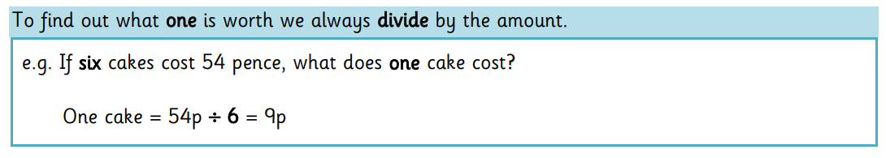

Help with Exercise 2:
2. Step 1
We need to find the price of 1 bubbly gum.
42 ÷ 7 = 6
Now we know:
1 bubbly gum = 6p
These questions have two steps…
3. Step 3:
We know how much 1 bubbly gum costs, but we want to find out how many 3 cost.
So, we multiply the cost of 1 bubbly gum (6p) by the amount we want (3).
6p x 3 = 18p.

1. First we need to look at the information we know.
7 bubbly gums = 42p
We want to find the cost of 3.

