Year 4 Maths – Ordering Numbers up to 1000.
- Please follow this link and work through the ‘Learn’ section - https://www.bbc.co.uk/bitesize/articles/zb86t39
- Once you have worked through ‘Learn,’ please complete the activities below.

Activity 1 – Optional
Activity 2 – Optional
Activity 3 – Below
Activity 4 – Mastery on ordering numbers.

Key Words:

Ascending – Smallest to Largest
Descending – Largest to Smallest
< - Smaller than
> - Larger than

Activity 3:
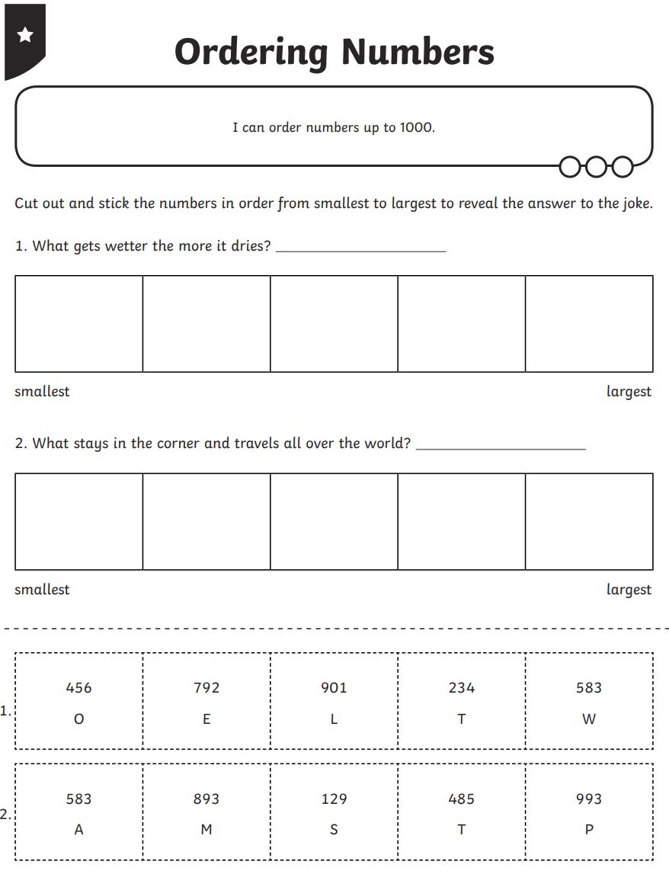
Green
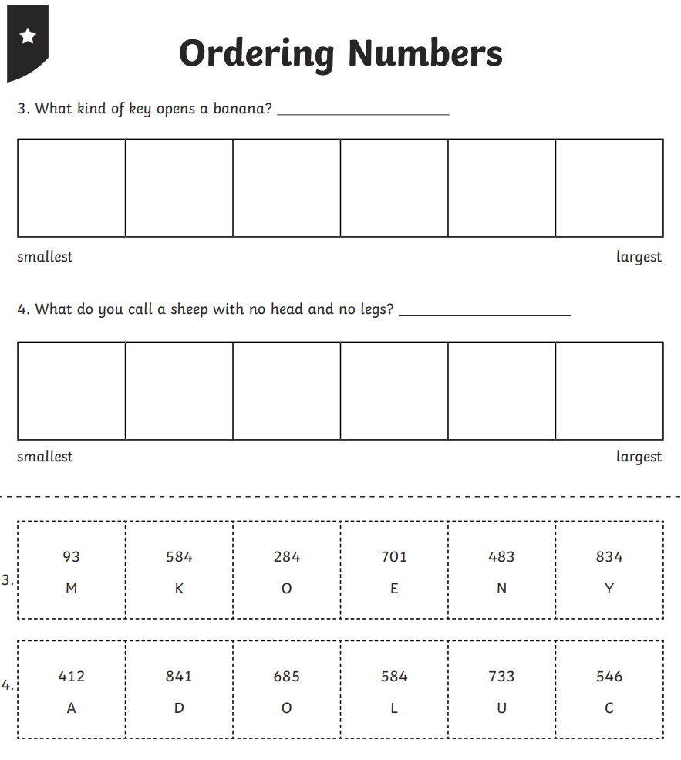

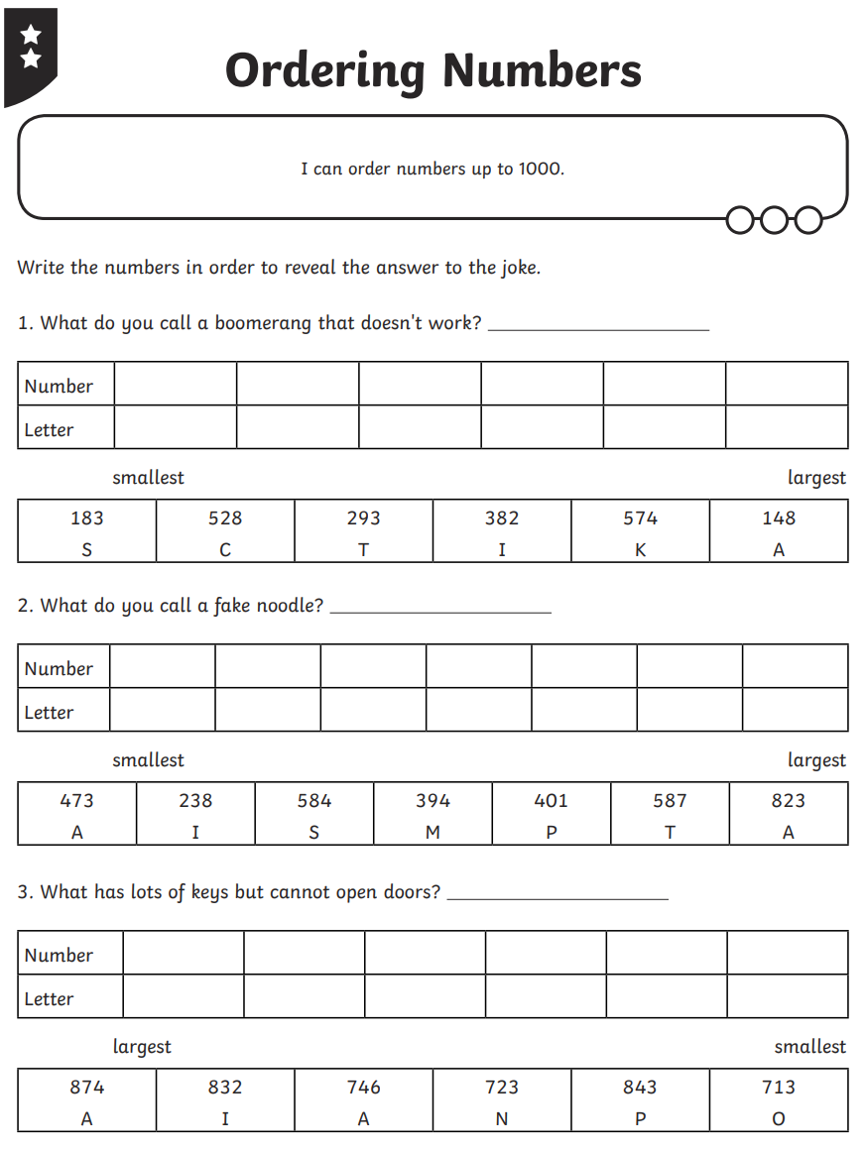
Red
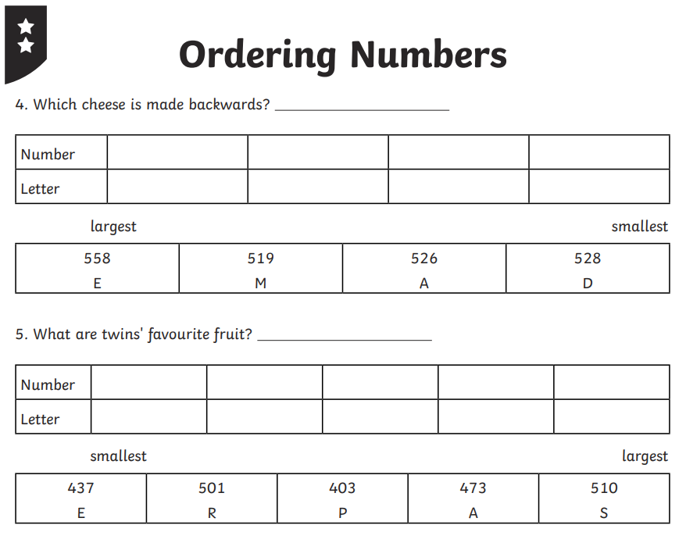

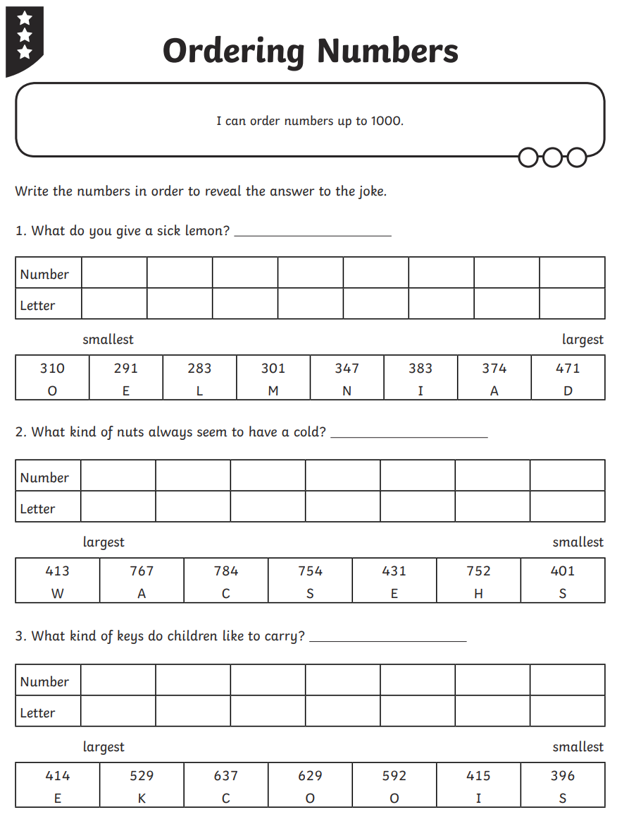
Blue
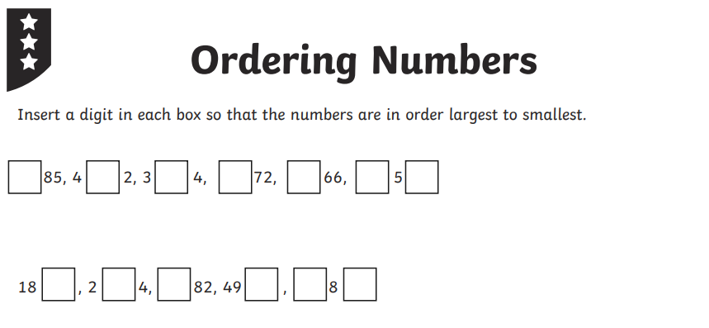

Activity 4: Mastery
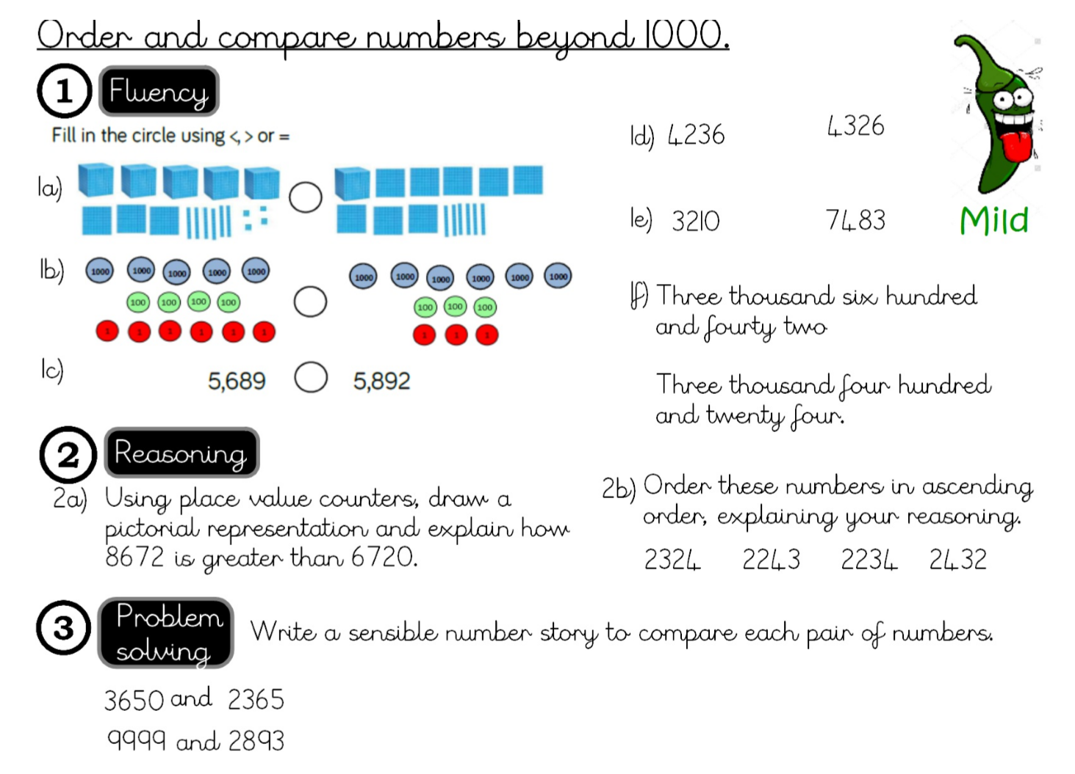
Green / Red

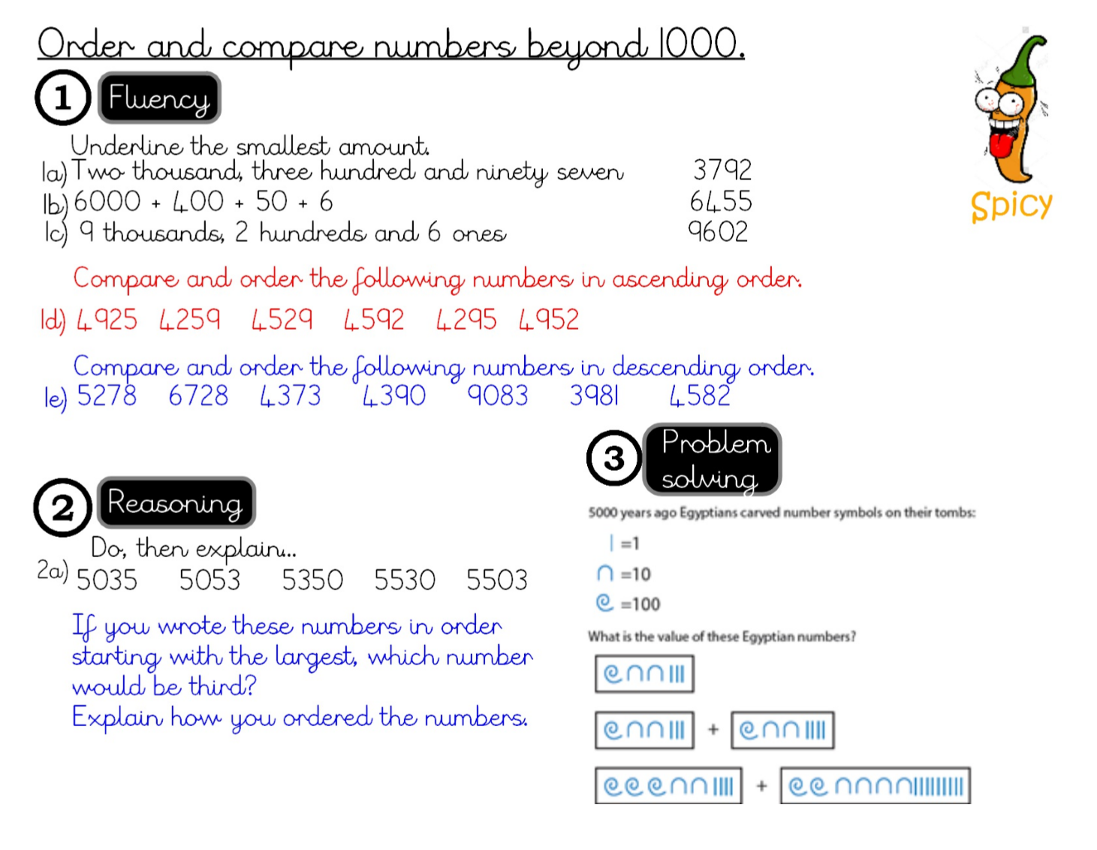
Blue

