Maths Yr 5
Go to the following page: https://www.bbc.co.uk/bitesize/articles/z47mkty
Watch the video comparing and ordering money.
Now try the activity
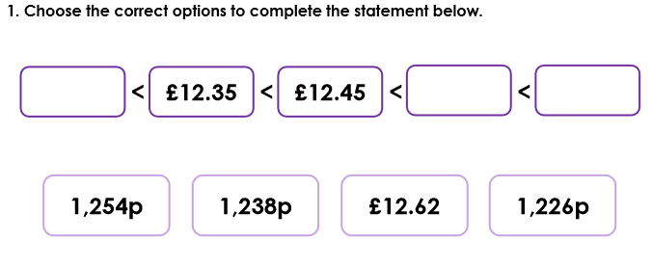
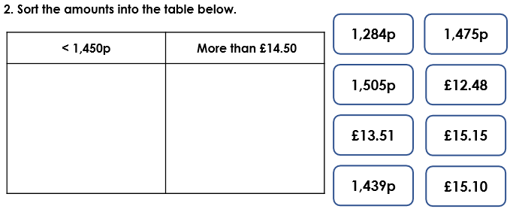

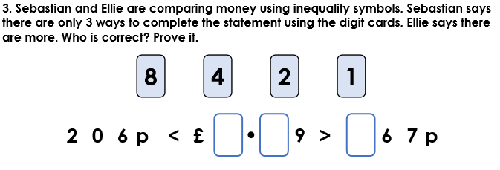
Answers
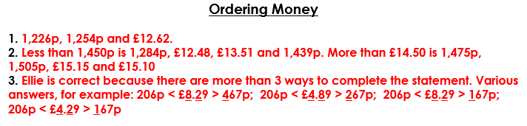

Now try activity 2 – The interactive game on the web site above.

