Maths year 5 Challenge
Go to the following web page if you have a protractor
https://www.bbc.co.uk/bitesize/articles/zdsrsk7
Watch the video and try the some of the questions below.

- Draw
- An angle measuring 65 degrees with one line measuring 6.5cm
- An obtuse angle measuring 136 degrees with one line measuring 5.4cm

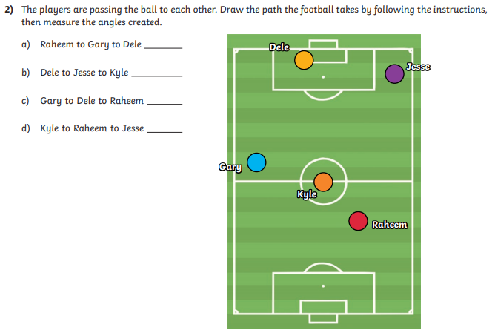

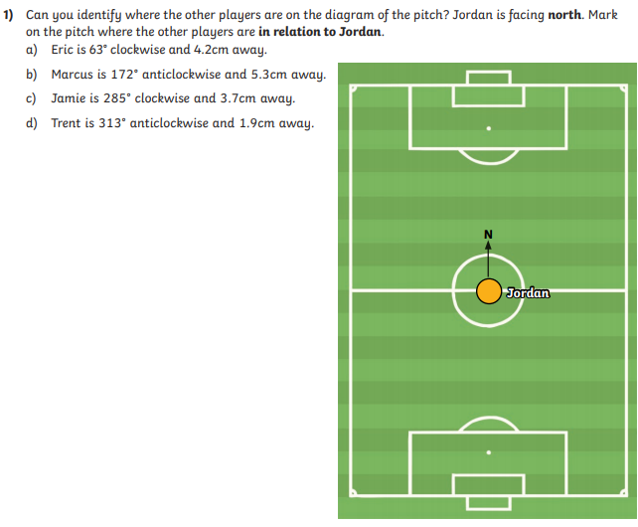
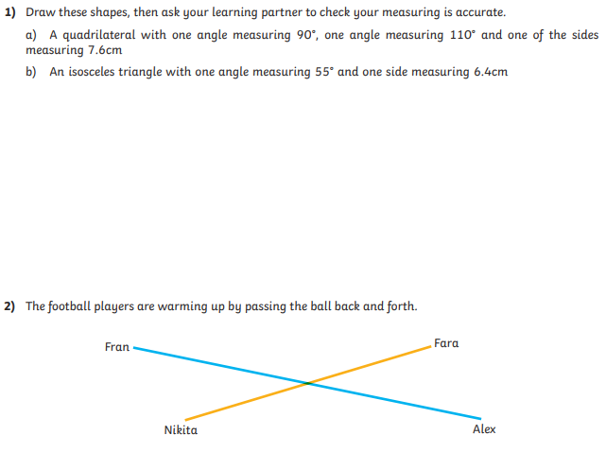

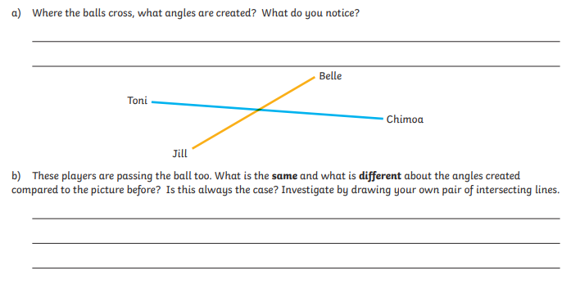

Find the answers below.

