Maths 17.6
Go to the following webpage:
https://www.bbc.co.uk/bitesize/articles/zynhjsg
Watch the video on percentages, decimals and fractions. Try the following:
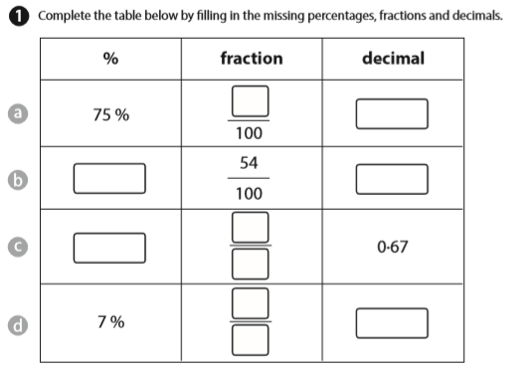

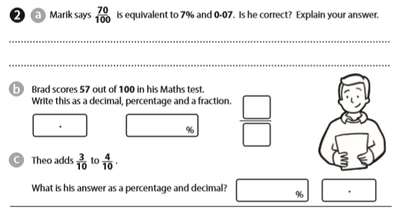
Answers
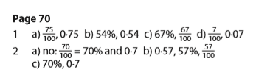

Now try
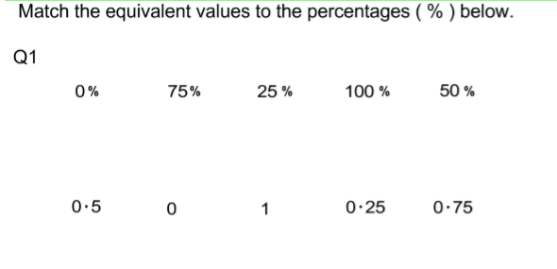
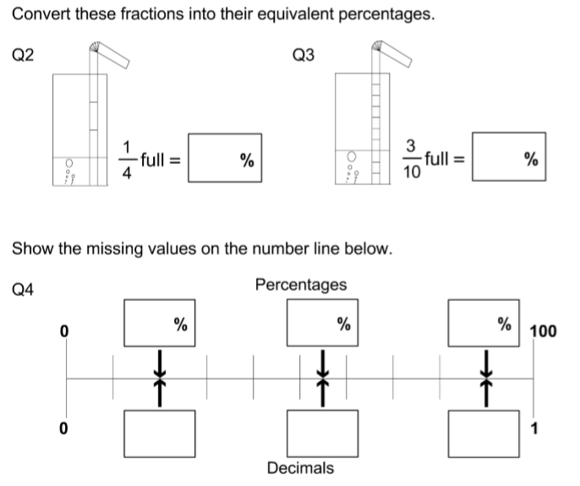
Answers
