Maths yr 6
Subtracting decimals with different places
Go to the following web page: https://www.bbc.co.uk/bitesize/articles/z6t3hcw
Watch the video and try the activities.
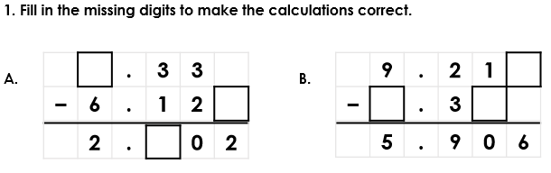
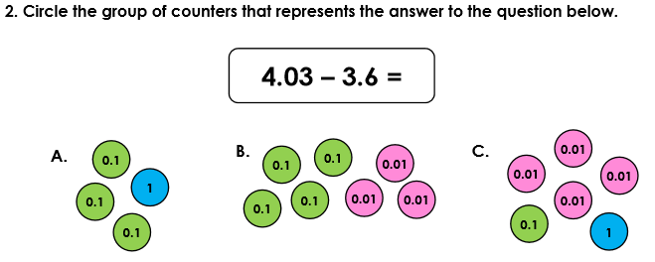
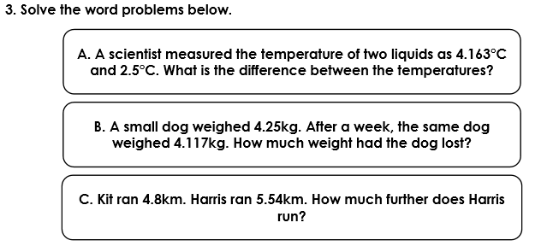
Answers
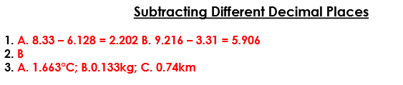

Now try the interactive activity 2 on the web site.

Now try these
