Maths yr 6
Go to the following web page:
https://whiterosemaths.com/homelearning/year-6/
Watch the video on Ratio – Lesson 1
Try the questions below. If you need more help, go to the following webpage: https://www.bbc.co.uk/bitesize/articles/z6tcf82

Attempt as many of these questions as you can.
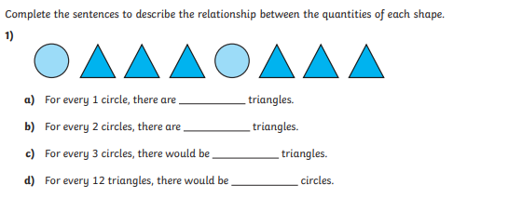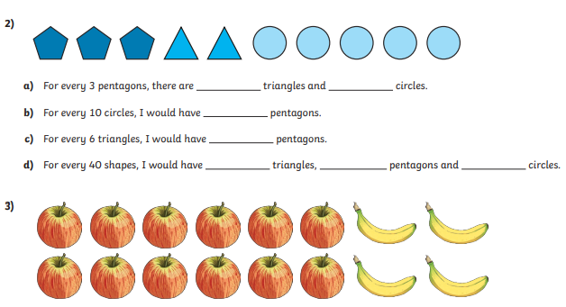
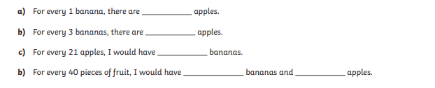

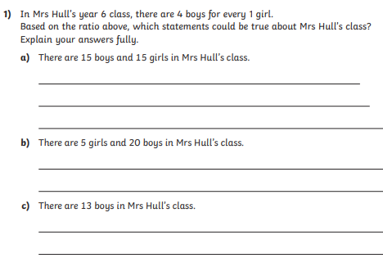
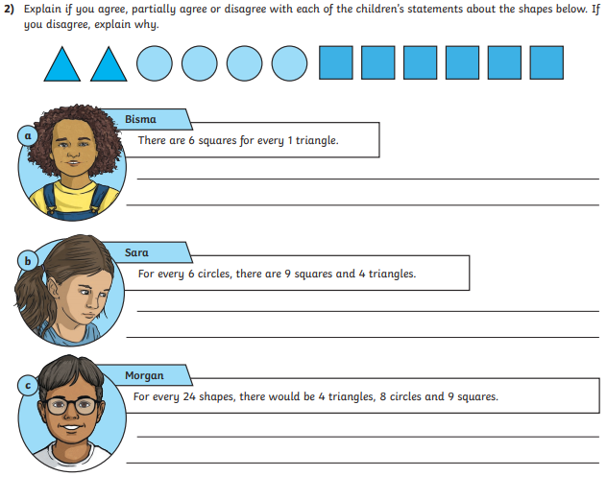
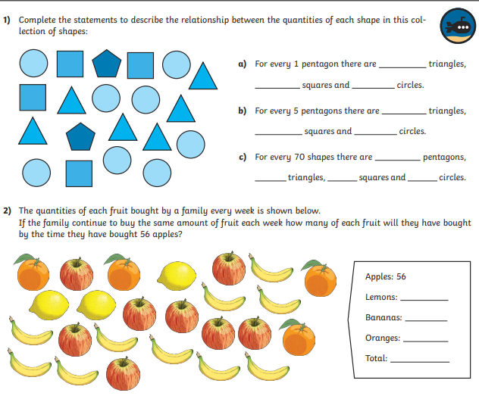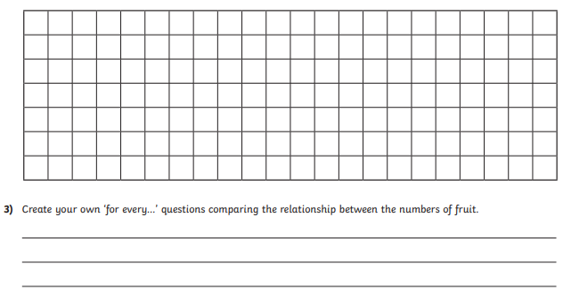

Find the answers below
