Maths - 8.6
Finding a rule
Go to the following website:
https://whiterosemaths.com/homelearning/year-6/
Watch the video on finding a rule.
Now try the following questions.
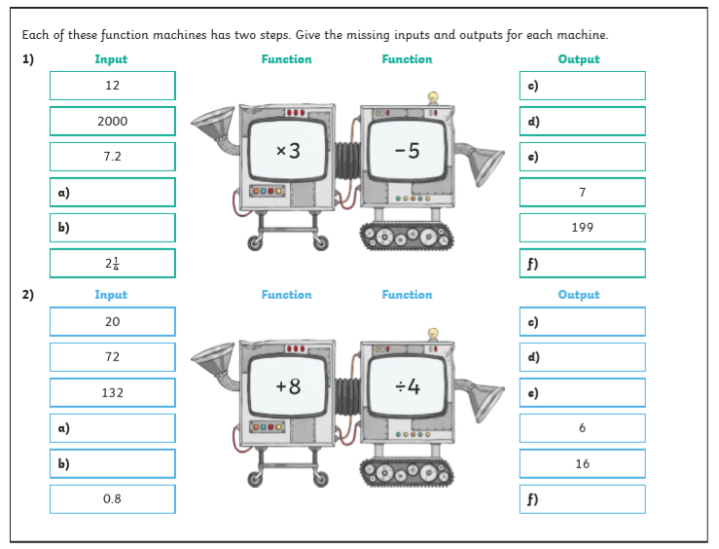

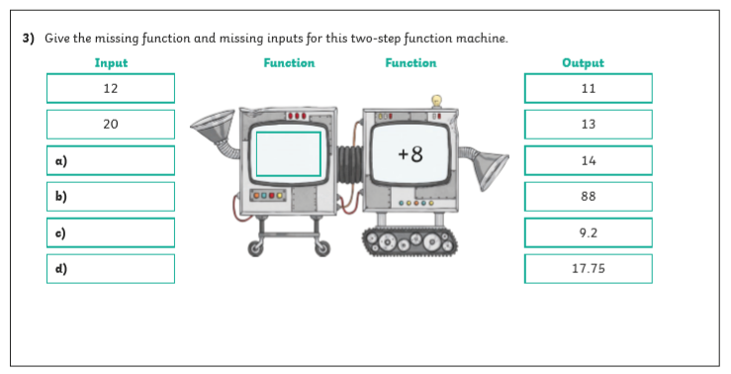

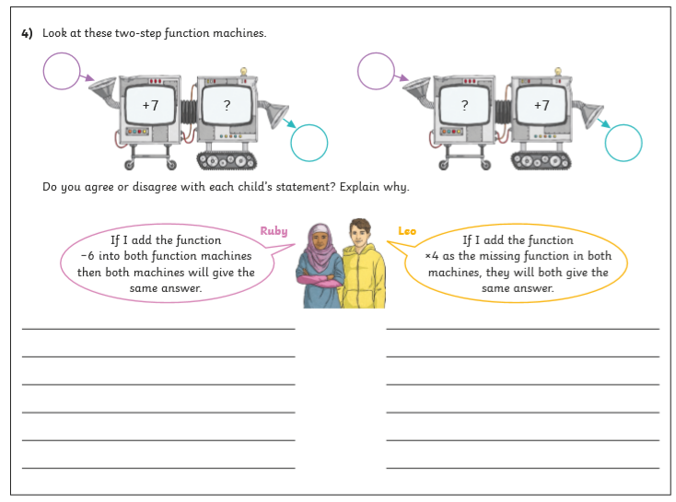

Find the answers below
