Maths 10.6
Understanding thousandths
Go to the following web page: https://www.bbc.co.uk/bitesize/articles/zx2dbqt
Watch the video and try the questions below.
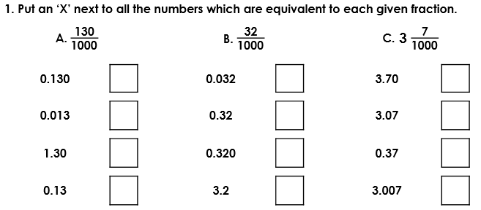

Watch the video again and attempt the following questions.

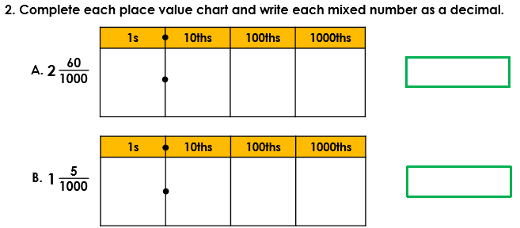

Try the following:
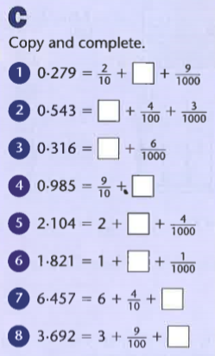

Find the answers below.
