Maths 8.6
Decimals as fractions
Go to the following webpage:
https://whiterosemaths.com/homelearning/year-5/
Watch the video and try the following: If your still unsure go to the following webpage:
https://www.bbc.co.uk/bitesize/articles/zrsc86f Do what you can.

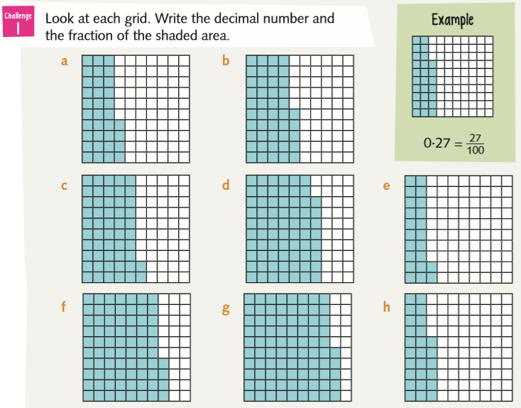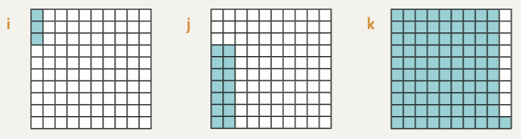

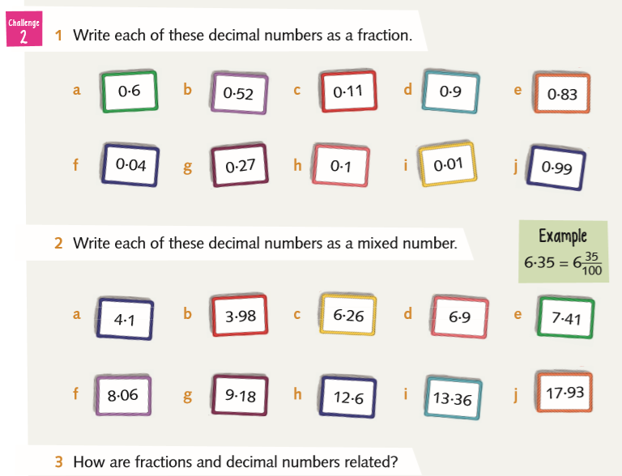
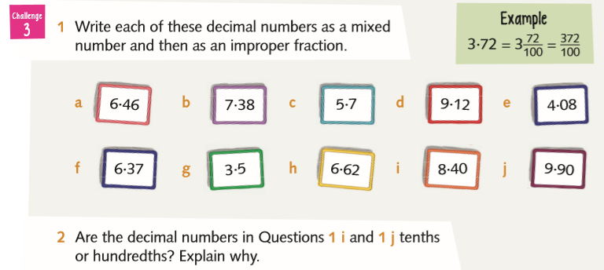

Find the answers below
