Maths 10.6 Forming expressions
Go to the following website:
https://whiterosemaths.com/homelearning/year-6/
Look at lesson 2 watch the video and have a go at the questions.

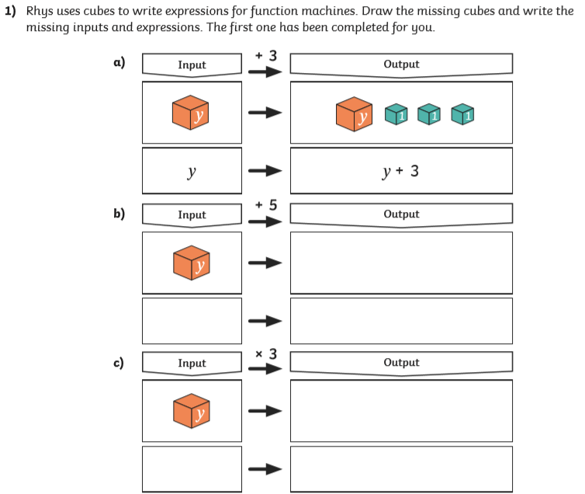
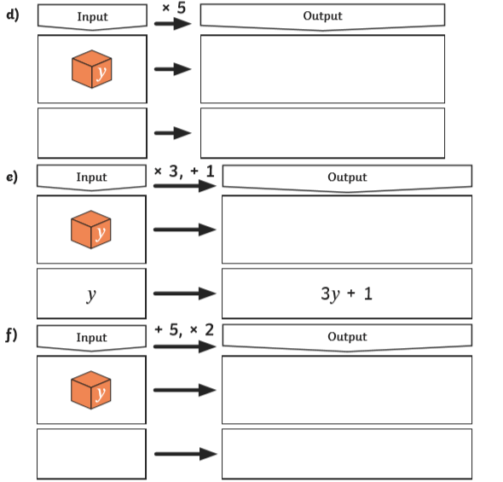
Find the answers below
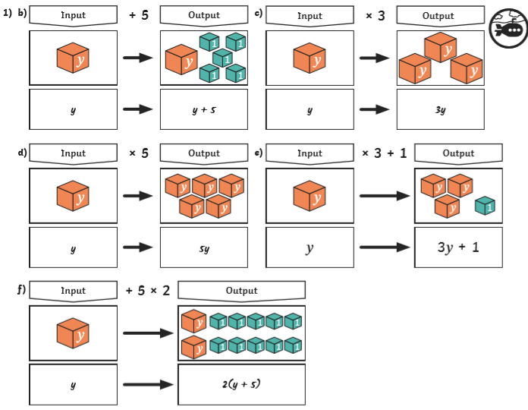

Now try
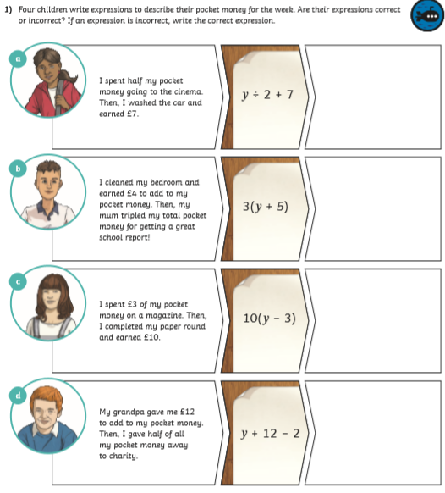

Find the answers below
