Religious Education: Sikhism
LQ: How do Sikh people worship?
Waheguru is the name given for God by the Sikhs.

Activity 1:
Create a simple spider diagram of what you already know about Sikhs. Think back to Term 2 when we learnt about Sikhism. Use the pictures below to help you.
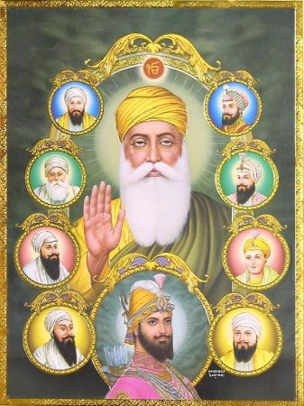

What do the 5ks represent?

Who are these men?
What is this symbol?
Why do they wear orange?

Sikhism

Activity 2:
Look at the pictures below. These are examples of how Sikhs worship god. Look at the pictures…
- What do you notice
4
3
2
1
6
5

Once you have gathered some ideas, try to match the pictures to the text. Ask your adult to help you read them.
- If you are unable to print, please match the numbers to each other starting with the number of the picture followed by the number of the text.
2
1

4
3

5
3

Activity 3:
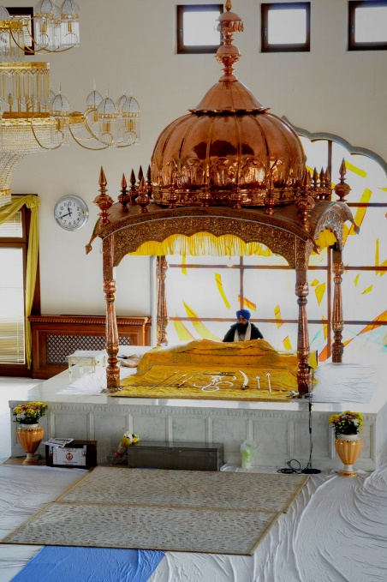
Watch this video on the Guru Granth Sahib: https://youtu.be/h2LbTwwGsAY

Once you have watched this, create a ‘Fact Page’ on how and where Sikhs worship God and Guru Granth Sahib.

- Make sure it is colourful.
- You can design it in any way.
- A Fact Page contains information.
- Make sure you use what you have learnt in the cards above and the video to help you gather your facts.

