RE 15.6
If Jesus was a king, what kind of kingdom would He have?

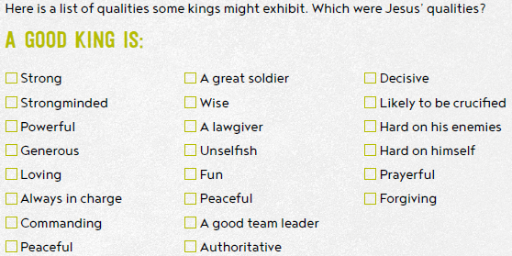
What evidence do you have to support your views?

Four things for you to think about.
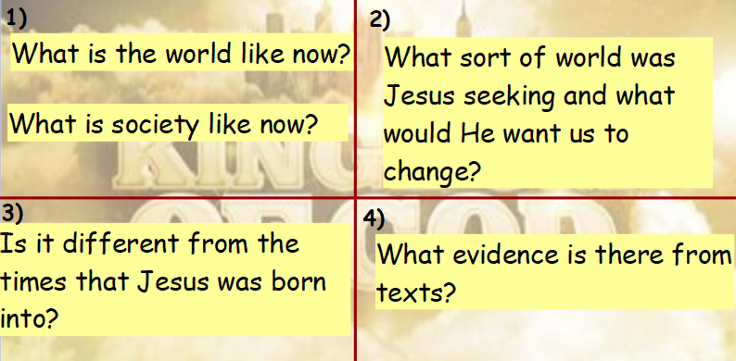

Look at these following scriptures from Mark in the Bible.
A) Mark 1: 30-34
B) Mark 1: 40-44
C) Mark 2:1-12
D) Mark 6: 30-44
E) Mark 8: 1-13
F) Mark 10:17-31

What does each of these scriptures show about the world Jesus was trying to create?

