Religious Education
LQ: Why do Sikhs believe in serving others?

1. Look at the pictures below and discuss the questions with your adult.
- What do you think is happening?
- What do you think will happen after these photos were taken?
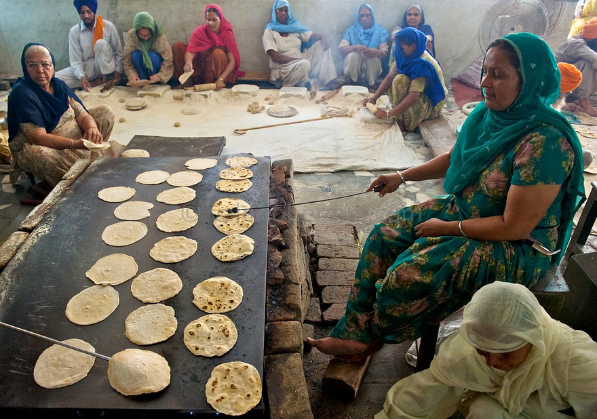
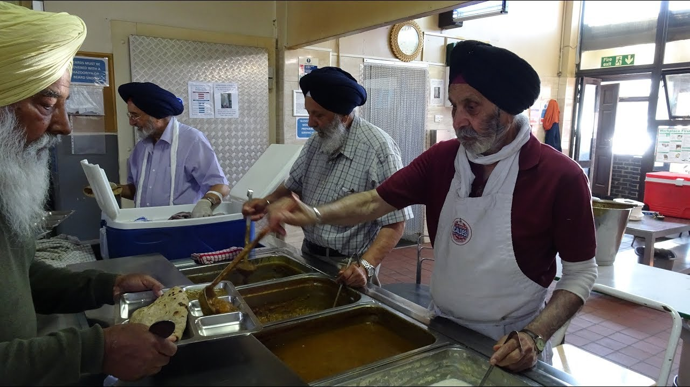

Watch these videos about Langar and Seva:
http://www.bbc.co.uk/education/clips/zvx6yrd

Activity
Green / Red / Blue
Fill in the Storyboard about the animated story of ‘Guru Nanak.’
- There are six boxes – Please split the story up into six parts and draw a picture for each section.
- Then write a short sentence to describe what is happening in each of the pictures.
- The storyboard is below.

