RE Year 6
The Kingdom of God
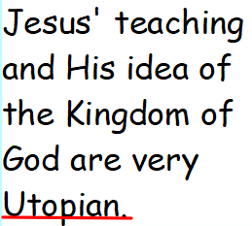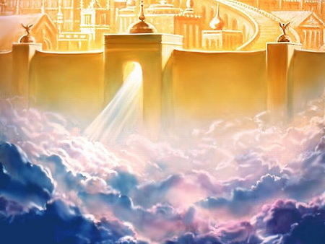

What does the word ‘utopia’ mean?
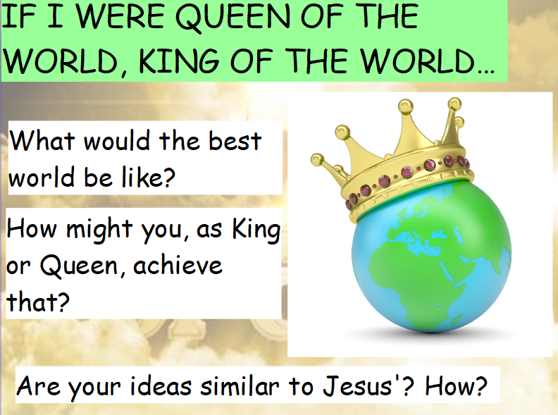

Activity
Create your own idea of Utopia as a poem, poster, leaflet or power point presentation.

