RE - 8.6
How is the Kingdom Of God Portrayed in Parables
Jesus told lots of stories that start: ‘The Kingdom of Heaven is like …’

I wonder what your idea of heaven is?

Read the following bible passages and answer the related questions.
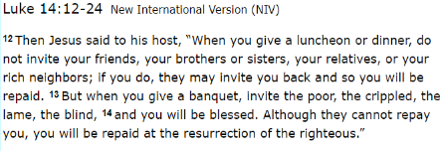
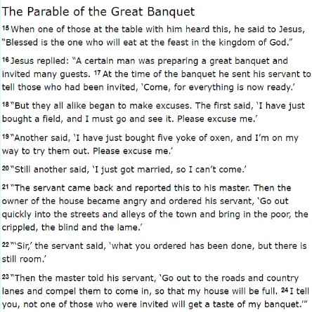
Questions
- How do you feel about this story?

- What do you think Jesus meant?

- Is the feast Heaven? Is the banquet Earth? Are they metaphors?

- Why do the rich and successful people not come?

- Is everyone welcome in the Kingdom of Heaven?

- Would everyone listening to Jesus be happy with His story?

Read the following parable.

Which of the two parables did you like the most? Why?

