Rabbits Home Learning 1.6.20
Please log in to your online phonics lesson at either 9.30am or 10 am.
Set 1 sounds (most children)
Set 2 sounds (4 children from Rabbits who joined the Y1 group)

Please email me if you’re not sure which group.

We will be using this as part of our home learning for the rest of this term.
https://www.youtube.com/channel/UCo7fbLgY2oA_cFCIg9GdxtQ

Writing
What do you do last week? I moved house, just around the corner but I had lots of packing and unpacking to do!
Draw a picture of something you did last week during the half term holiday.
Parents: Ask your child to tell you something about their picture. Help them think of a simple sentence and try to write it using initial sounds for each word and writing any whole words they remember.
Please don’t write it for them!

Maths
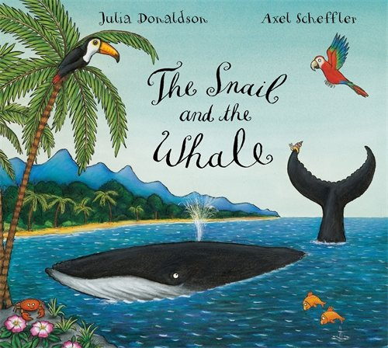
Read this story or listen to it being read to you using the link below.
https://www.youtube.com/watch?v=EmMnaSkeKqQ
Lots of activities will be based on this story this week.
https://whiterosemaths.com/homelearning/early-years/
Use the link below to complete the activities.

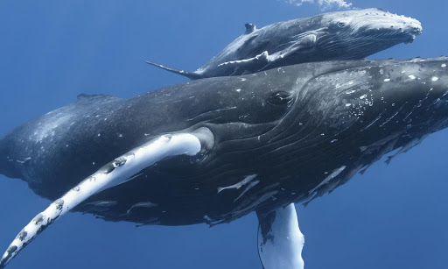
Can you find out any facts about whales?
Where do they live?
What do they eat?

For more activities please email me and to email me pictures of the work you have been doing…
Rgolden@charing.kent.sch.k

