Rabbits Home Learning 3.6.20

Please log in to your online phonics lesson at either 9.30am or 10 am.
Set 1 sounds (most children)
Set 2 sounds (4 children from Rabbits who joined the Y1 group)

Please email me if you’re not sure which group.

We will be using this as part of our home learning for the rest of this term.
https://www.youtube.com/channel/UCo7fbLgY2oA_cFCIg9GdxtQ

Writing
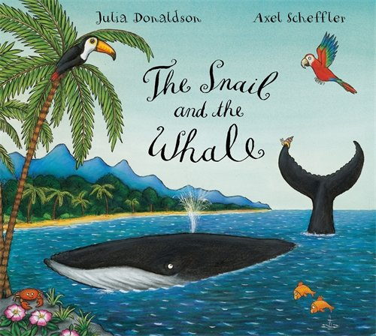
Please use the worksheet provided to get your child to write some simple sentences about what they can see. For example,
‘I can see a whale.
I can see a snail.’
If you can print it off, get your child to write on the sheet, if not, find some paper and draw them some lines so they can write on the lines.

Maths
Please continue with this week’s activities based on the story this week, ‘The Snail and the Whale’.
https://whiterosemaths.com/homelearning/early-years/
Use the link below to complete the activities.
Try day 3 and 4.

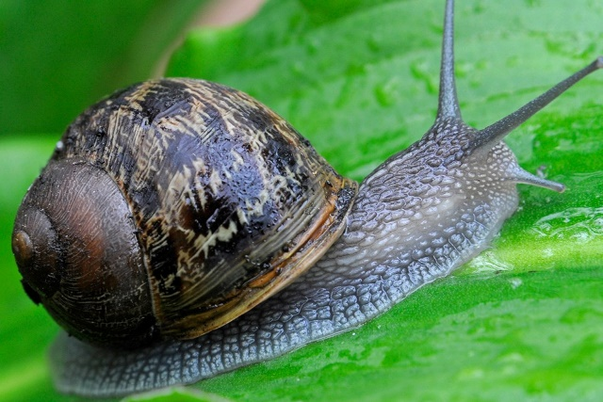
Can you find a snail outside? Be careful not to hurt or damage it.
Where did you find it?
Can you send me a photo of it?

For more activities please email me and to email me pictures of the work you have been doing…
Rgolden@charing.kent.sch.k

