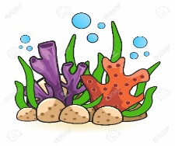**Rabbits Home Learning 22.06.2020**

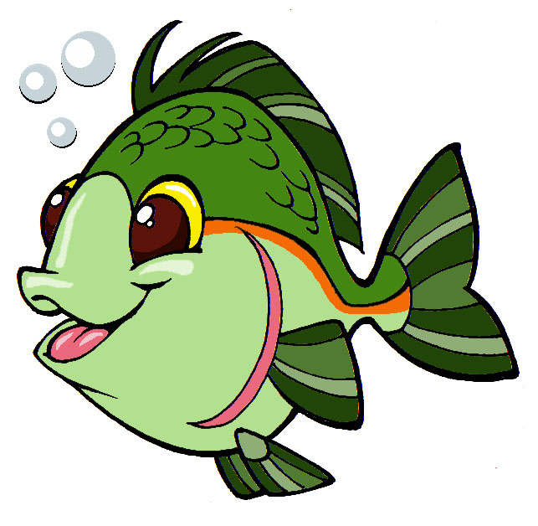

**Phonics**

*Please log in to your online* ***phonics*** *lesson at either 9.30am or 10 am.*

*Set 1 sounds (most children)*

*Set 2 sounds (4 children from Rabbits who joined the Y1 group)*

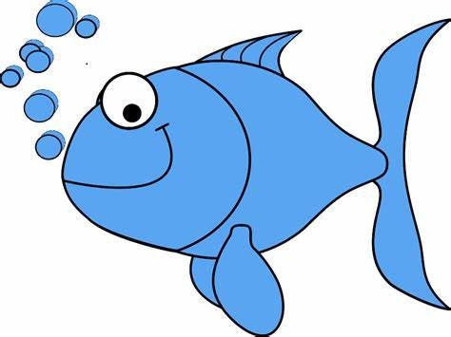

Please email me if you’re not sure which group.

We will be using this as part of our home learning for the rest of this term.

<https://www.youtube.com/channel/UCo7fbLgY2oA_cFCIg9GdxtQ>

**Writing**

<https://youtu.be/VnKmWZBd2LQ>

**“Commotion in the Ocean”**

Today we are going to imagine we are deep in the ocean and the Great Blue whale is our teacher for the day and he needs to make a sea life report for the dolphins. He would like us to hide behind the rocks and watch the sea creatures come and go. The turtles are very busy burying their eggs and Angel fish is looking so very pretty. What else can you see? Write down in sentences beginning with…

I can see…………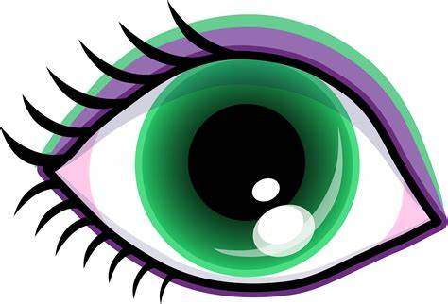

I can hear…….….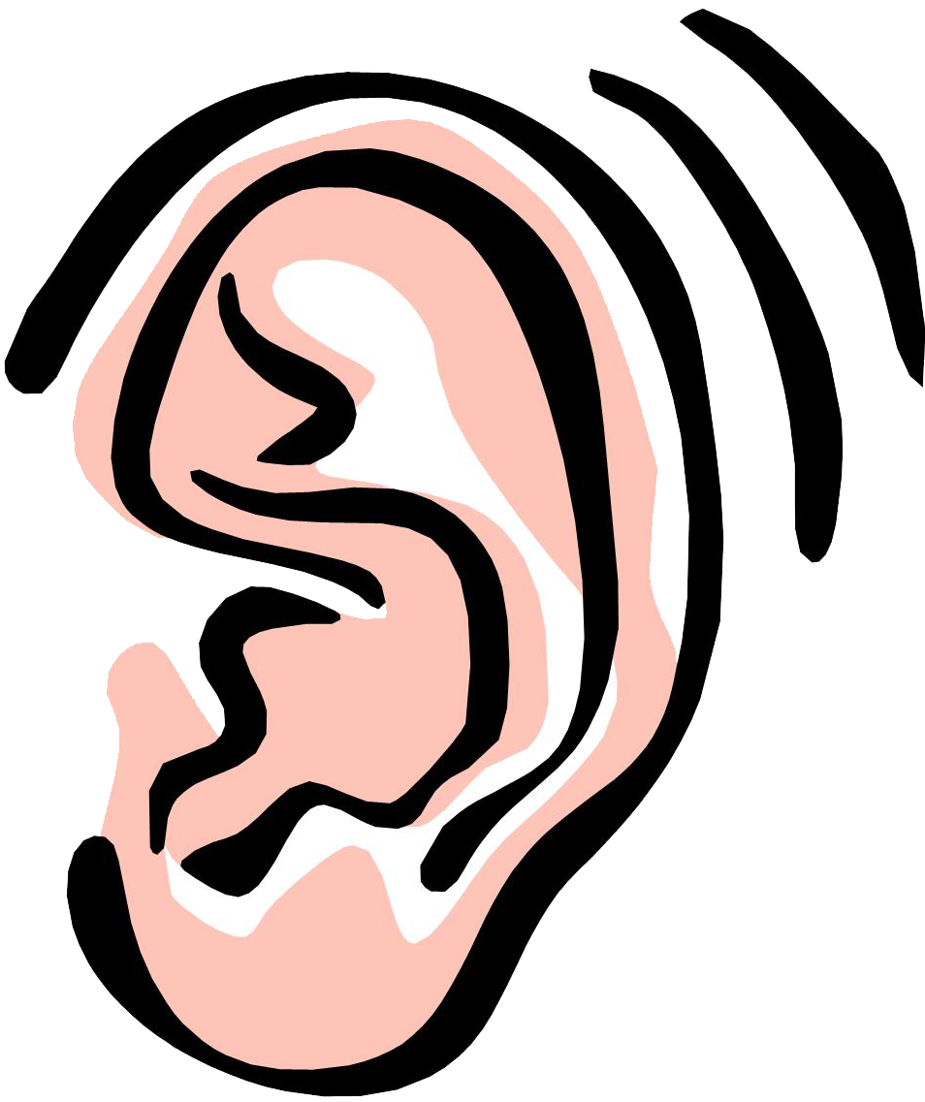

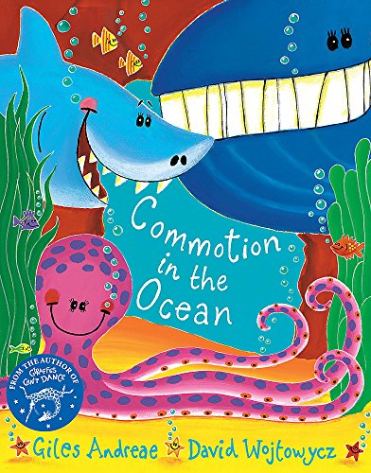

**Maths**

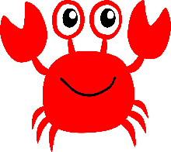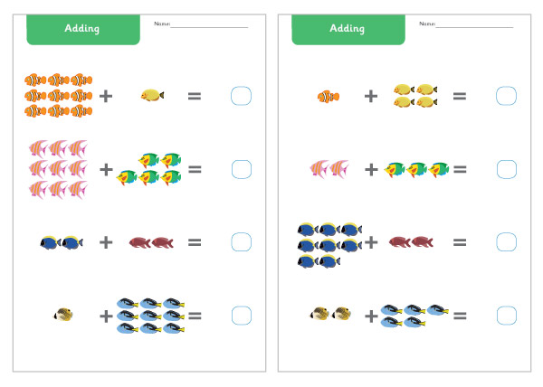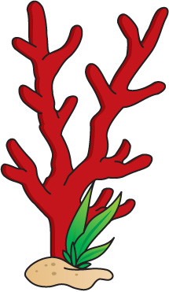1+9=

Please draw 9 sea creatures below. The crab is feeling lonely and would like some friends to play hide and seek with.

**Arts and crafts**

Art activities you may like to try

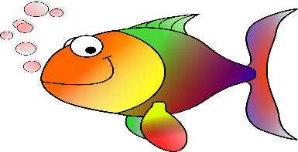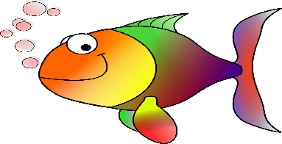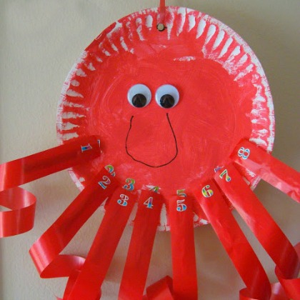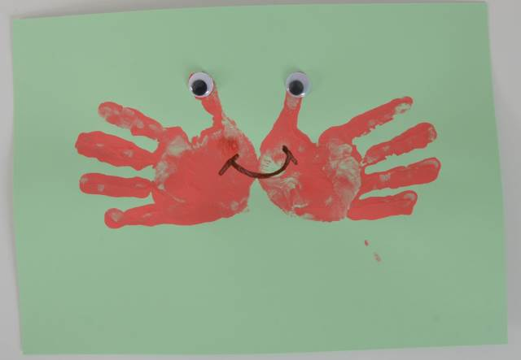

Make sure you take a photo of your art work to show Mrs Golden and Mrs Nunn.