Rabbits Home Learning 5.6.20

Please log in to your online phonics lesson at either 9.30am or 10 am.
Set 1 sounds (most children)
Set 2 sounds (4 children from Rabbits who joined the Y1 group)

Please email me if you’re not sure which group.

We will be using this as part of our home learning for the rest of this term.
https://www.youtube.com/channel/UCo7fbLgY2oA_cFCIg9GdxtQ

Writing
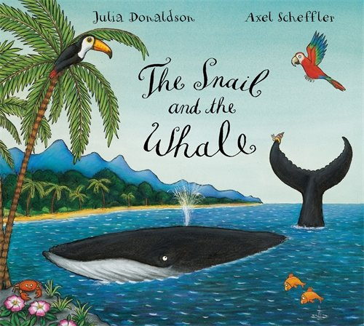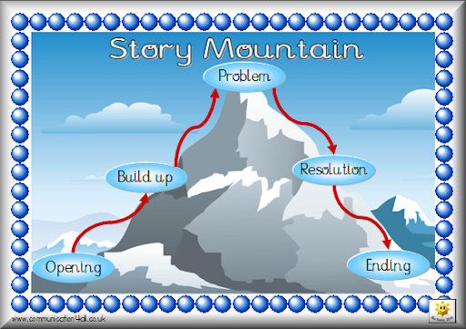
ending
solution
problem
Build up
beginning
Make a story mountain of ‘The Snail and the Whale’. Draw pictures to show what happens throughout the story.

Maths
Please continue with this week’s activities based on the story this week, ‘The Snail and the Whale’.
https://whiterosemaths.com/homelearning/early-years/
Use the link below to complete the activities.
Complete the activities for day 5.

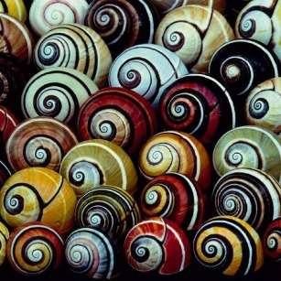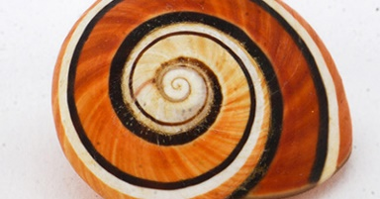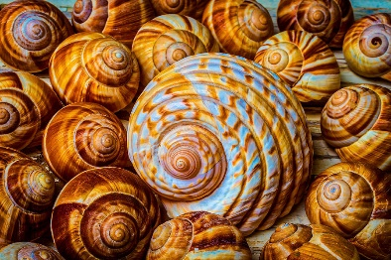

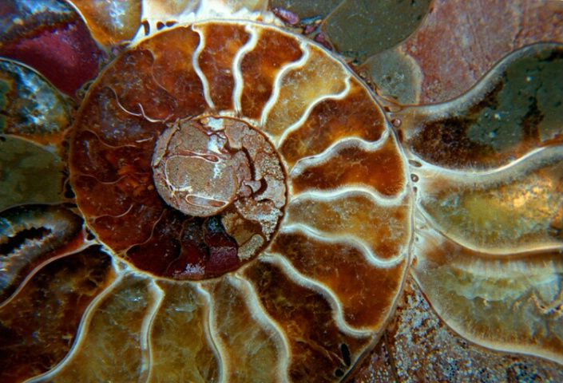
Look at these pictures of snail shells. Can you make your own pattern on a snail shell? Ask a grown up to draw a shell for you. Use any colours you want to.

Can you make your own snail?
I love the one made with food! Once you’ve made it, you can eat it!
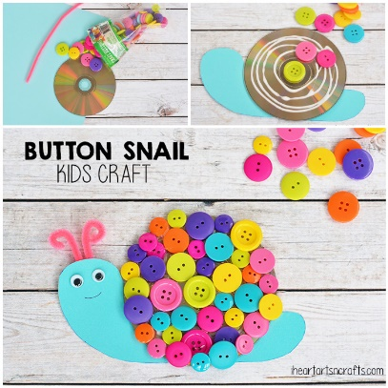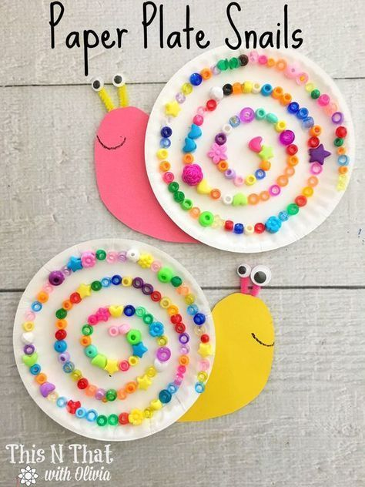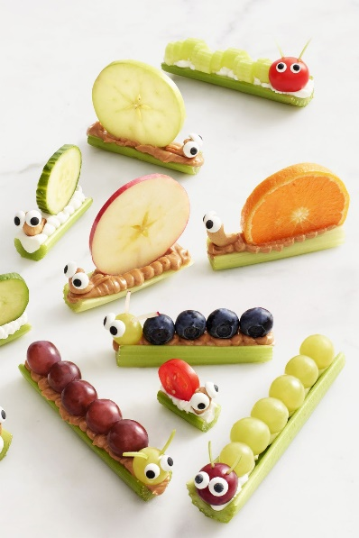

For more activities please email me and to email me pictures of the work you have been doing…
Rgolden@charing.kent.sch.k

