Rabbits Home Learning 5.6.20

Please log in to your online phonics lesson at either 9.30am or 10 am.
Set 1 sounds (most children)
Set 2 sounds (4 children from Rabbits who joined the Y1 group)

Please email me if you’re not sure which group.

We will be using this as part of our home learning for the rest of this term.
https://www.youtube.com/channel/UCo7fbLgY2oA_cFCIg9GdxtQ

Writing
https://www.youtube.com/watch?v=babXCIRMjQM
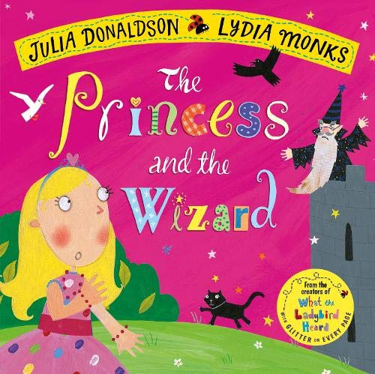
This is the story we are using this week.
Use the link above to listen to the story being read.

Maths
This week’s activities are all based on the story above.
https://whiterosemaths.com/homelearning/early-years/
Use the link below to complete the activities.
Complete the activities for day 1 and 2

Get creative!!
Can you dress up as a princess or a wizard like the characters in our story?
Can you think of your own magic spell?
What would you change into to escape from the wizard?
You’ll also find a princess dress design and a wizard cut out on the class page to print out.

For more activities please email me and to email me pictures of the work you have been doing…
Rgolden@charing.kent.sch.k

