Rabbits Home Learning 5.6.20

Please log in to your online phonics lesson at either 9.30am or 10 am.
Set 1 sounds (most children)
Set 2 sounds (4 children from Rabbits who joined the Y1 group)

Please email me if you’re not sure which group.

We will be using this as part of our home learning for the rest of this term.
https://www.youtube.com/channel/UCo7fbLgY2oA_cFCIg9GdxtQ

Writing
https://www.youtube.com/watch?v=babXCIRMjQM
If you haven’t already, listen and watch the story being read using the link above.
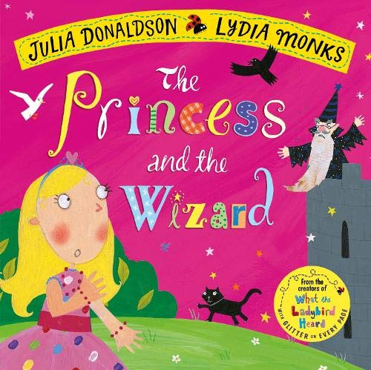
Draw the different things Princess Eliza changes into… have a go at writing what they are.
For example, write ‘a yellow chick’.
Parents- please don’t worry if your child cannot spell every word correctly. They should be using their initial sounds to write the sounds they can hear.

Maths
This week’s activities are all based on the story above.
https://whiterosemaths.com/homelearning/early-years/
Use the link below to complete the activities.
Complete the activities for day 3 and 4

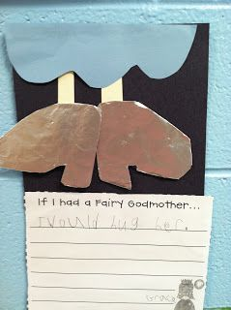
If you had a Fairy Godmother, what would you ask her for?
Can you tell a grown up or make a picture like this one and write your ideas?

For more activities please email me and to email me pictures of the work you have been doing…
Rgolden@charing.kent.sch.k

