Rabbits Home Learning 15.6.20

Please log in to your online phonics lesson at either 9.30am or 10 am.
Set 1 sounds (most children)
Set 2 sounds (4 children from Rabbits who joined the Y1 group)

Please email me if you’re not sure which group.

We will be using this as part of our home learning for the rest of this term.
https://www.youtube.com/channel/UCo7fbLgY2oA_cFCIg9GdxtQ

Writing
https://www.youtube.com/watch?v=babXCIRMjQM
If you haven’t already, listen and watch the story being read using the link above.
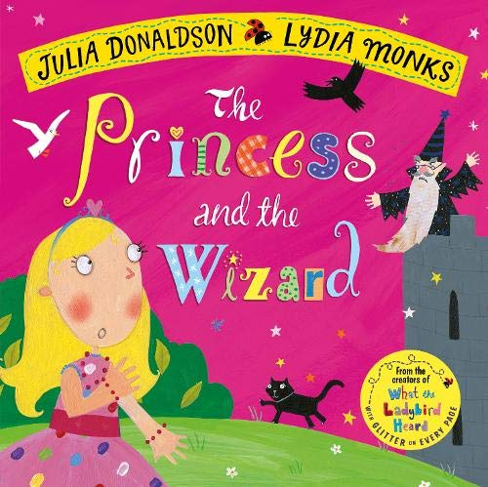
Can you make a spell for the Fairy Godmother to turn the wizard into stone?

What would go into the spell?
Draw and write the words.

Maths
This week’s activities are all based on the story above.
https://whiterosemaths.com/homelearning/early-years/
Use the link below to complete the activities.
Complete the activities for day 5.

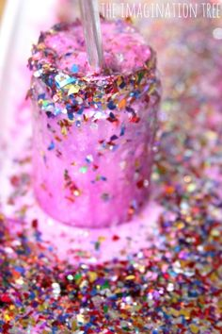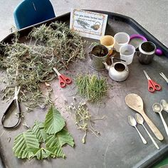
Make a magic potion.
You can use anything you have at home, but check with Mum or Dad first!
You could even use grass and soil!

For more activities please email me and to email me pictures of the work you have been doing…
Rgolden@charing.kent.sch.k

