Rabbits Home Learning 17.6.20

Please log in to your online phonics lesson at either 9.30am or 10 am.
Set 1 sounds (most children)
Set 2 sounds (4 children from Rabbits who joined the Y1 group)

Please email me if you’re not sure which group.

We will be using this as part of our home learning for the rest of this term.
https://www.youtube.com/channel/UCo7fbLgY2oA_cFCIg9GdxtQ

Reading/Writing
Make a card for your Mum or Dad.
Find out what their favourite things are and draw those pictures on the card.
Write a message inside.

Maths
Join in with this measuring song, there are lots of actions to join in with too!
https://www.bbc.co.uk/teach/supermovers/ks1-maths-length-height/zdrx92p

Can you find things in your house that are long and short?
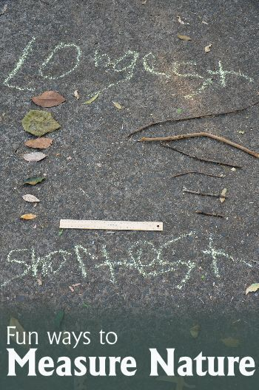
Challenge your Mum or Dad to find the longest stick or the shortest leaf.
Can you order them?
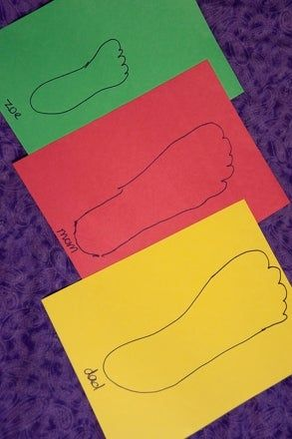
Whose feet are the longest?
Are anyone’s feet the same length?

For more activities please email me and to email me pictures of the work you have been doing…
Rgolden@charing.kent.sch.k

