Rabbits Home Learning 19.6.20

Please log in to your online phonics lesson at either 9.30am or 10 am.
Set 1 sounds (most children)
Set 2 sounds (4 children from Rabbits who joined the Y1 group)

Please email me if you’re not sure which group.

We will be using this as part of our home learning for the rest of this term.
https://www.youtube.com/channel/UCo7fbLgY2oA_cFCIg9GdxtQ

Reading/Writing

Maths
Join in with this measuring song, there are lots of actions to join in with too!
https://www.bbc.co.uk/teach/supermovers/ks1-maths-length-height/zdrx92p
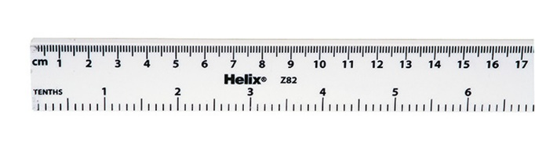
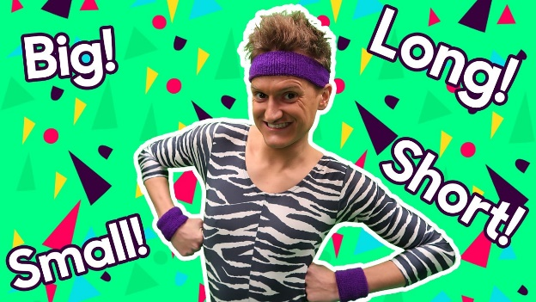

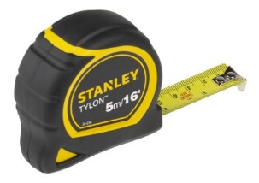
Today for your activity, ask someone in your house if they have a ruler or a tape measure.
What do you notice about it? Can you find markings on it which say cm. This is centimetres and it’s what we measure short things in.
Can you see where it says 10cm or 20 cm? Can you find something that it 10cm long?
How many sea creatures can you think of?
Have you been to the beach?
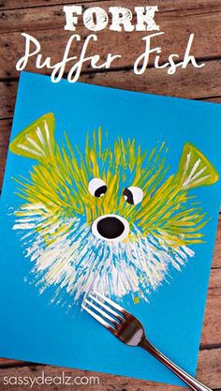
Use paint and a fork to make your own puffer fish picture!

For more activities please email me and to email me pictures of the work you have been doing…
Rgolden@charing.kent.sch.k

