Religious Education:
A question to discuss with your parent:
- What do you think it means to be at the heart of a community?
- Can you give any examples of places that might be classed as the heart of the community?

Statement:
‘People say that the Gurdwara is at the heart of the Sikh community.’

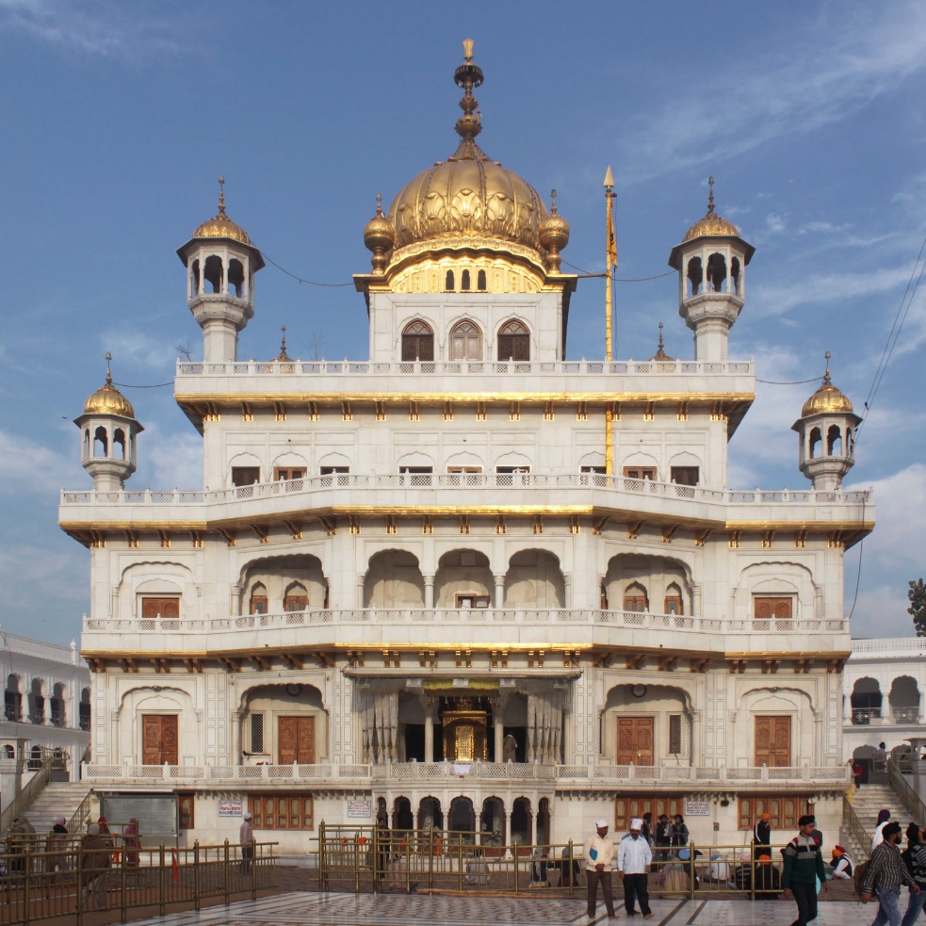
Gurdwara: A Sikh Temple

Watch this video, where Simran talks about the Gurdwara and why it is important: https://youtu.be/BjHfAuq1K8E
Questions to Discuss:
- How does the Sikh community support its local community?

- Why does the Gurdwara have a sports hall, day centre and a Punjabi school?

Look at this Information from Guru Nanak Darbar in Gravesend: http://gurunanakdarbar.org http://gurunanakdarbar.org/newsletter/

- Look at the different activities at the Gurdwara. How might these different people use the Gurdwara?

Activity:

Create a poster to advertise the Gurdwara at Gravesend.

Please include:
- 3 activities and a brief explanation of them.
- 2 speech bubbles of what others have to say.
- Name/ pictures.

There is some information on the ‘Guru Nanak Day Centre’ which is part of a Gurdwara as well as two people that speak about their own experiences of being part of the Gurdwara:

Guru Nanak Day Centre:
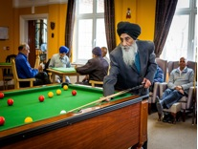
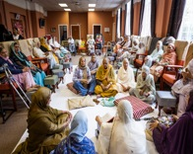
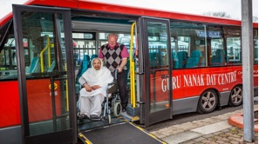
Our aim is to provide a warm and friendly service, which could be called ‘a home from home’ for older people from all cultural backgrounds. The need for services is greater as the change in social and economic structure has had greater effect on the extended family structure. So the need of language and culturally appropriate services is important as older people often feel isolated
The Guru Nanak Day Centre provides day care services to older people aged 60 plus, Monday – Friday 9am - 5pm and in addition has a drop in service at the weekends from 12 noon to 5pm. Transport is provided for those who need it. Refreshments and healthy Asian meals are available in line with individual dietary needs at a set cost.

Our trained bi-lingual staff not only provide support but also promote well being, enabling older people to live safely and independently in their local community.
At GNDC we provide the following range of services and activities
- Drop in centre
- Transport to and from the centre for frail
- Comfortably furnished lounges with satellite TV, video and music system.
- Separate facilities for male and female (as upon their wishes)
- Library books
- Ethnic and English newspapers
- Social recreational and educational activities
- Light refreshments
- Fresh healthy Asian meals, along with a diabetic menu for service users with specific dietary needs
- Exercise and leisure
- Healthy cooking sessions and advice
- Religious activities
- Music and Art / Craft Therapy
- Advice
- Day Trips
On going fund raising events and donations received have enabled us to transform the outdoor space by planting raised beds with herbs and plants so that the service users can enjoy the gardens throughout the year.

Comments on the Guru Nanak Day Centre:
