Science:
This week you will be learning about a balanced diet.
- Watch this video: https://www.bbc.co.uk/bitesize/topics/zrffr82/articles/zppvv4j
- Think about what makes up a balanced, healthy diet.
- Follow through the PowerPoint named ‘Healthy Eating’ to give you some more information.
- There is also an activity to complete on the PowerPoint as well as the one below.

Activity:
Make an engaging poster on a healthy, balanced diet. (There are some examples below).
You must include:
- What makes up a healthy and balance diet?
- Why is it good to have a balanced diet?
- What makes each part of a healthy diet good?

Some helpful websites:
https://www.healthline.com/health/balanced-diet#importance
https://www.nhs.uk/live-well/eat-well/

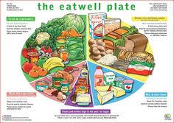
Poster Examples:

