Science:
Hello Foxes,
In Science last week, you made a poster about what makes up a healthy, balanced diet. This week, you will be making your own meal which includes all the food groups.
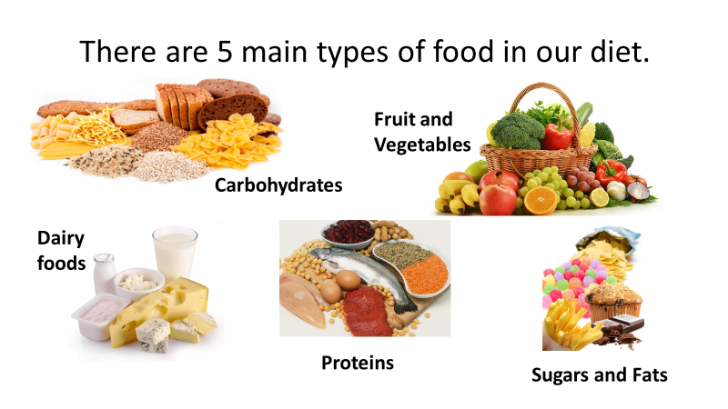
Look below at the food groups.
Now it it’s your turn! Follow the instructions below to create a simple meal that will include all of the food groups.
Sandwich Meal

- Find 2 pieces of bread.

- Butter the slices of bread.

- Place a type of meat onto once of the slices (E.g. Ham)

- Next, pick a vegetables or some fruit to have with your sandwich.

- Lastly, find some crisps to have with your meal.

Activity 1:

Read through the instructions above and find where I have included each of the ‘Food Groups.’
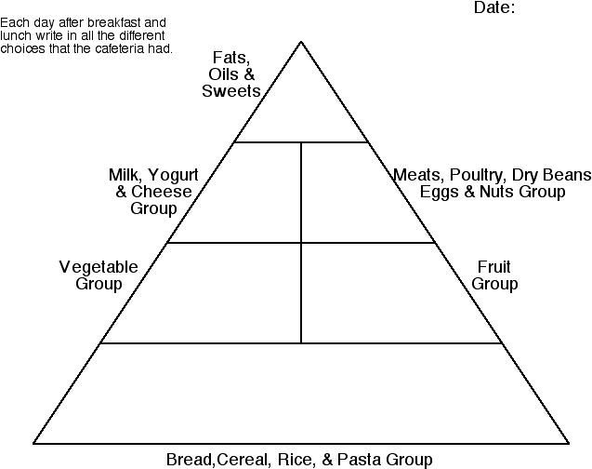
Once you have done that, add a picture of the food to the pyramid below in the correct part:

Activity 2:
Make the ‘Sandwich Meal’ for your family.
Have fun!

