Science:
LQ: How does nutrients or food get transported through the body.
- Please click and watch the video: https://www.bbc.co.uk/bitesize/topics/z27kng8/articles/z9wk7p3
- Next, imagine that you are eating some nutrients or food
- Where do you think the food goes and how do you think it travels through your digestive system?
- Complete the flow chart below on what parts of the body, your food travels through. (Add more sections to the flow chart if needed)

- 2.

3. 4.

5.

Nutrients is passed through the body via the ‘Digestive System.’
The ‘Digestive System’ is what breaks down your food and drink into substances which can then be passed around the body for energy, growth and tissue repair.
- Please watch this video to see how it is done: https://www.youtube.com/watch?v=ZBZWgrfZFbU

Activity:
Green / Red

- Watch the video to help you label the numbered parts of the ‘Digestive System’ below.
- Label the organs that the food passes through to allow nutrients to pass into the body.
- Add some key words for each of the organs to explain what happens at each point.

Blue
- Watch the video to help you label the numbered parts of the ‘Digestive System’ below.
- Label the organs that the food passes through to allow nutrients to pass into the body.
- Add a sentence for each of the organs to explain what happens at each point.

Green / Red
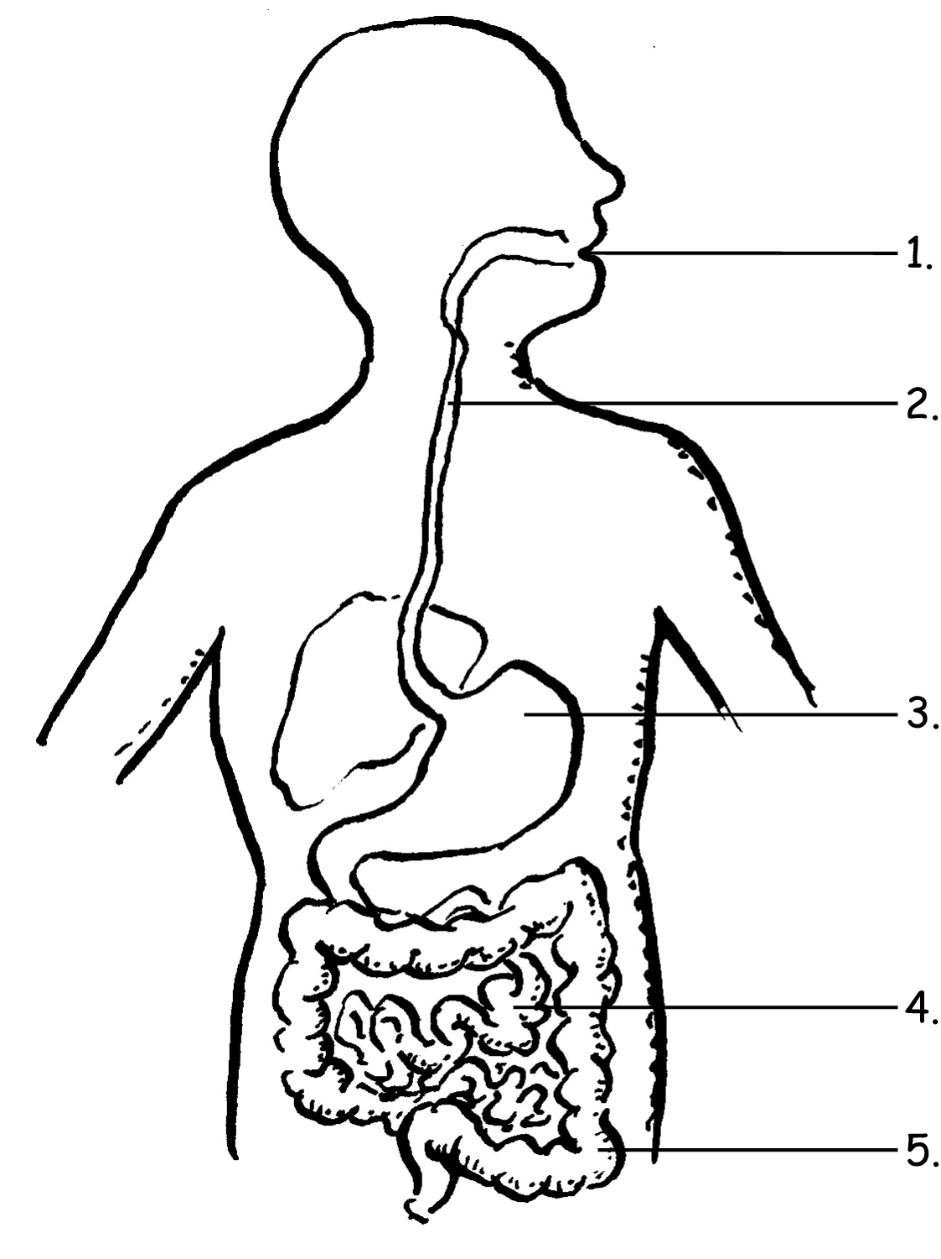
1. _________________

2. _________________

3. _________________

5. _________________

4. _________________

Blue
5. ______________
…………………………………………………………………………………………………………………………………………………………………………………………………….

4. ______________
…………………………………………………………………………………………………………………………………………………………………………………………………….

3. ______________
…………………………………………………………………………………………………………………………………………………………………………………………………….

2. ______________
…………………………………………………………………………………………………………………………………………………………………………………………………….

1. ______________
…………………………………………………………………………………………………………………………………………………………………………………………………….

