Science Yr5
Reversible and Irreversible changes.
Go to the following website: https://www.bbc.co.uk/bitesize/topics/zcvv4wx/articles/z9brcwx
Activity 1
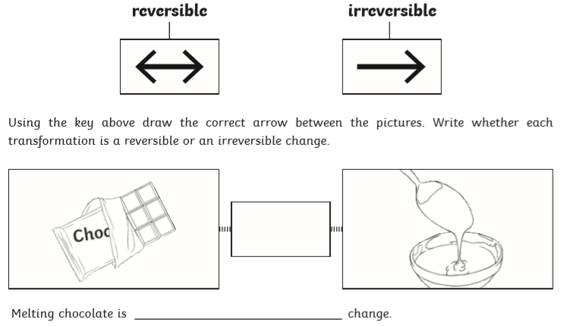
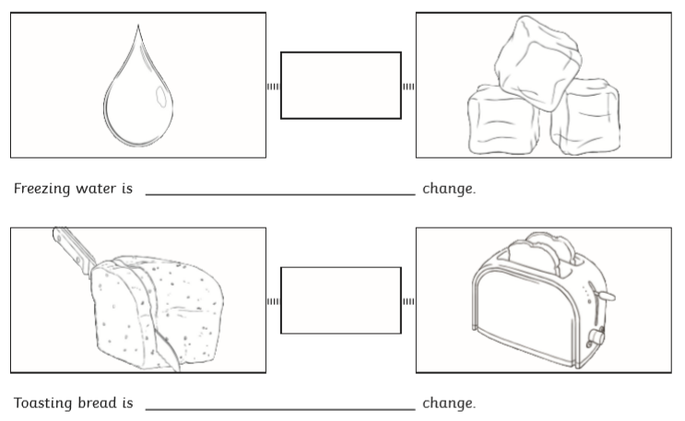

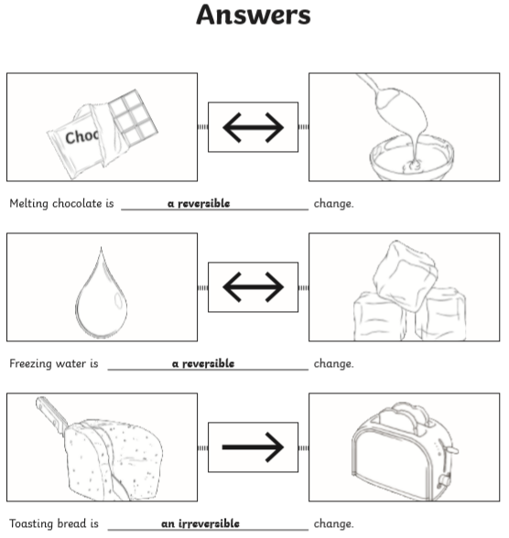

Watch the following video on solids, liquids and gases.

https://www.bing.com/videos/search?q=bbc+bitesize+changing+state+from+liquid+to+gas&&view=detail&mid=CB0A2BDFD8ECC8AACF6ACB0A2BDFD8ECC8AACF6A&&FORM=VRDGAR&ru=%2Fvideos%2Fsearch%3Fq%3Dbbc%2520bitesize%2520changing%2520state%2520from%2520liquid%2520to%2520gas%26qs%3Dn%26form%3DQBVR%26sp%3D-1%26pq%3Dbbc%2520bitesize%2520changing%2520state%2520from%2520liquid%2520to%2520gas%26sc%3D0-46%26sk%3D%26cvid%3DB44DF8879E5640D9B8C7F3A5294FEA4D

Activity 2
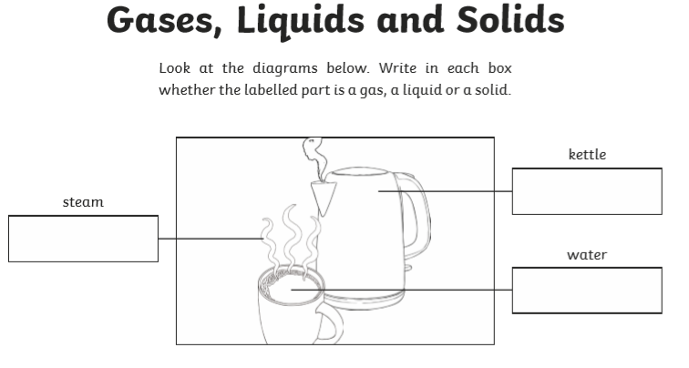
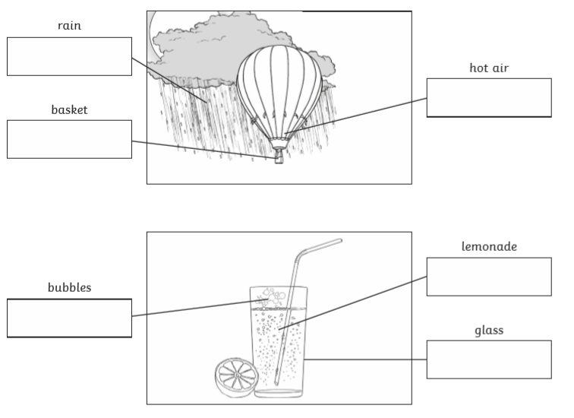

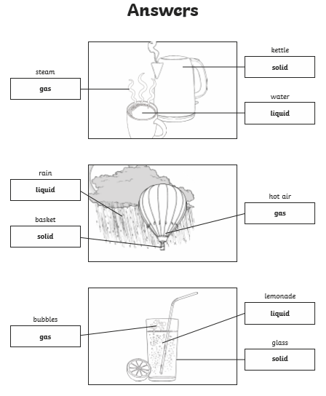

Watch the following video: https://www.bbc.co.uk/bitesize/topics/zgwxfg8/articles/zjq3rj6

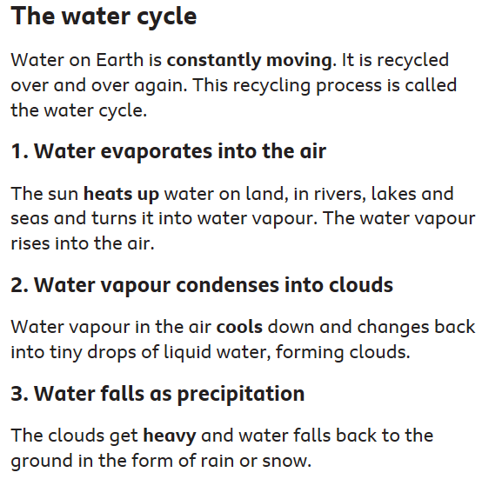
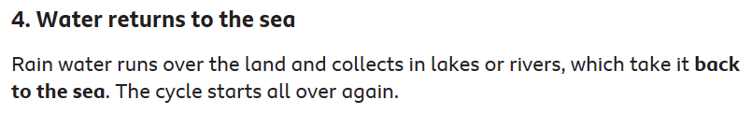

Activity 3
