Spelling Mr Bird’s group
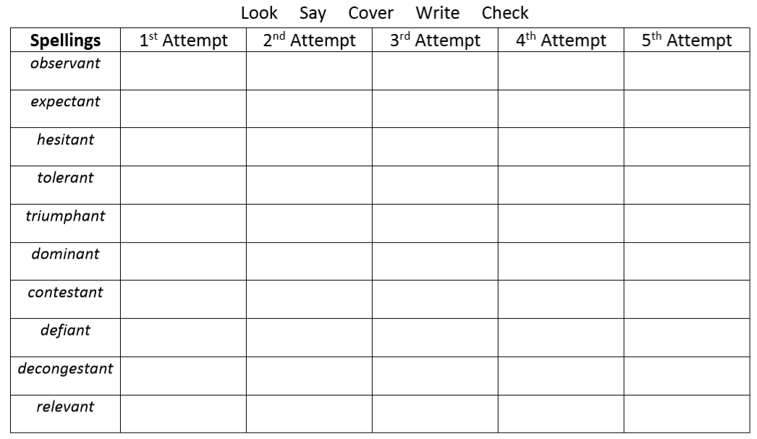
Use five of these words correctly in sentences of your own.

