Spellings 15.6
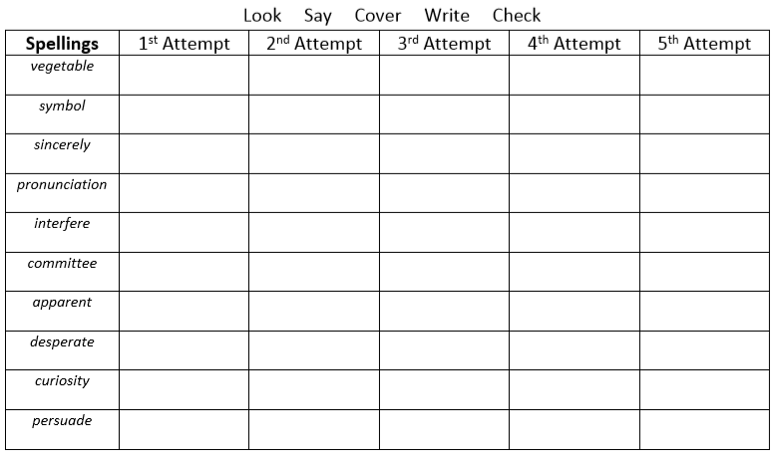
Challenge – How many mnemonics can you create to help you remember these words?
Eg Because – Big elephants can always understand small elephants.

