Squirrels Class – Art
Year 1 and 2

Van Gogh Starry Night

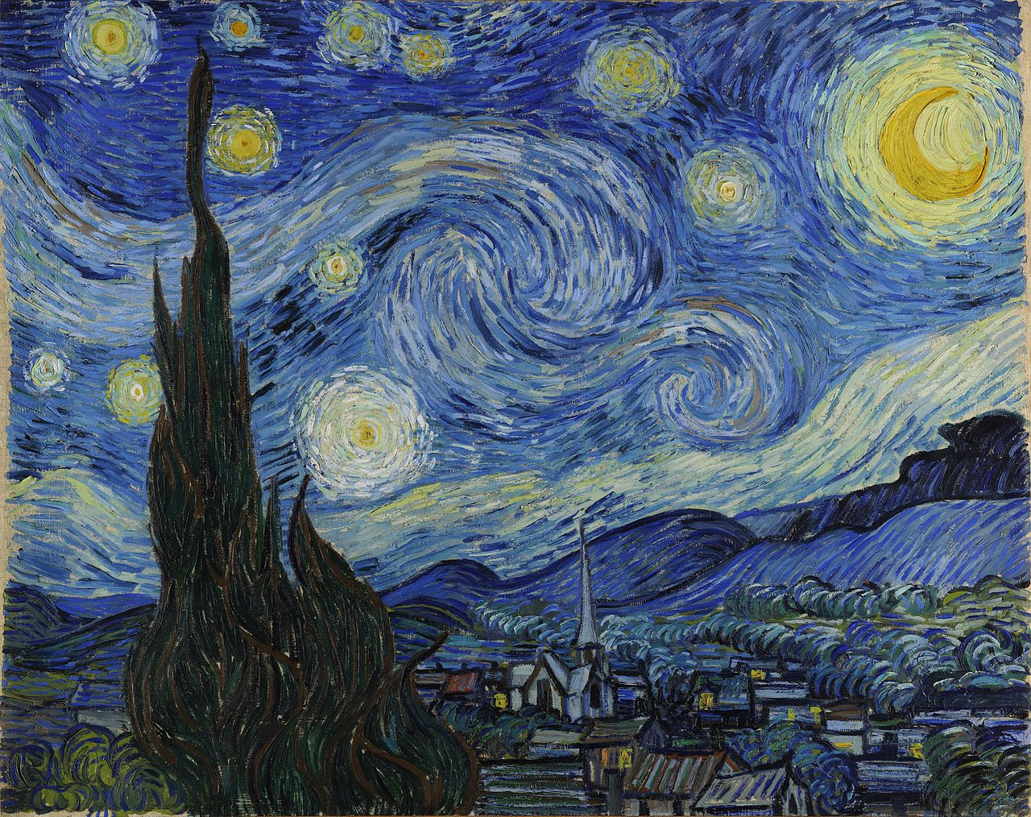

Here is a step by step tutorial of creating this piece of art using crayons (or oil pastels). If you do not have crayons, just give it a go using colour pencils.

https://www.youtube.com/watch?v=FLNU6dPi93s&feature=emb_title

