Squirrels – English
Year 2
Please see the attached reading comprehension activity. There are three levels of work in the same document. 1 * is the easiest, 2* medium and 3*trickiest. The answers are included. Choose a level and don’t peek at the answers before you’ve tried the questions!

Year 1
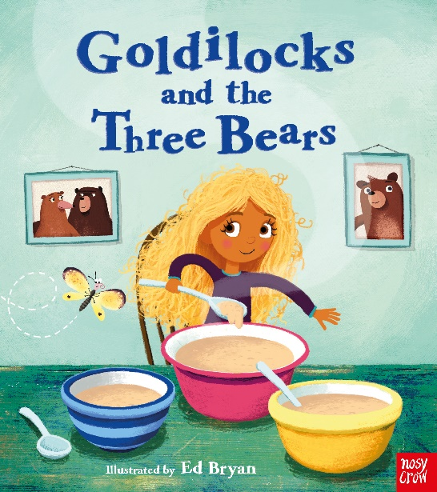

Look at this image. What do you see? Can you write some words around it? For eg spoon. Can you try and use your sounds to write some sentences beginning with ‘I can see…’. Remember to use a capital letter at the beginning and a full stop at the end.

