Squirrels – English
Year 1 and 2
Use the link to access today story.
https://www.youtube.com/watch?v=5gleDVbPFww&feature=emb_title

Here is a simple story map to show the sequence of events:
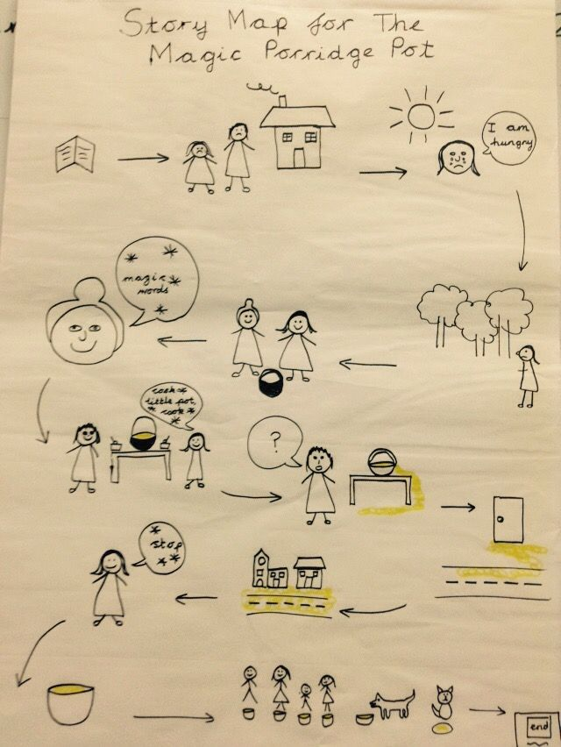
Your activity today is to draw a new story map, making some changes to the original story.
You might change the main characters. Perhaps a wizard gives a magic pot to a little boy. What food might the pot cook…could it be something different to porridge? Perhaps it’s a younger brother or sister who sets the pot cooking. You might even like to change the story ending. Use this original story map as a guide.

