Squirrels – English
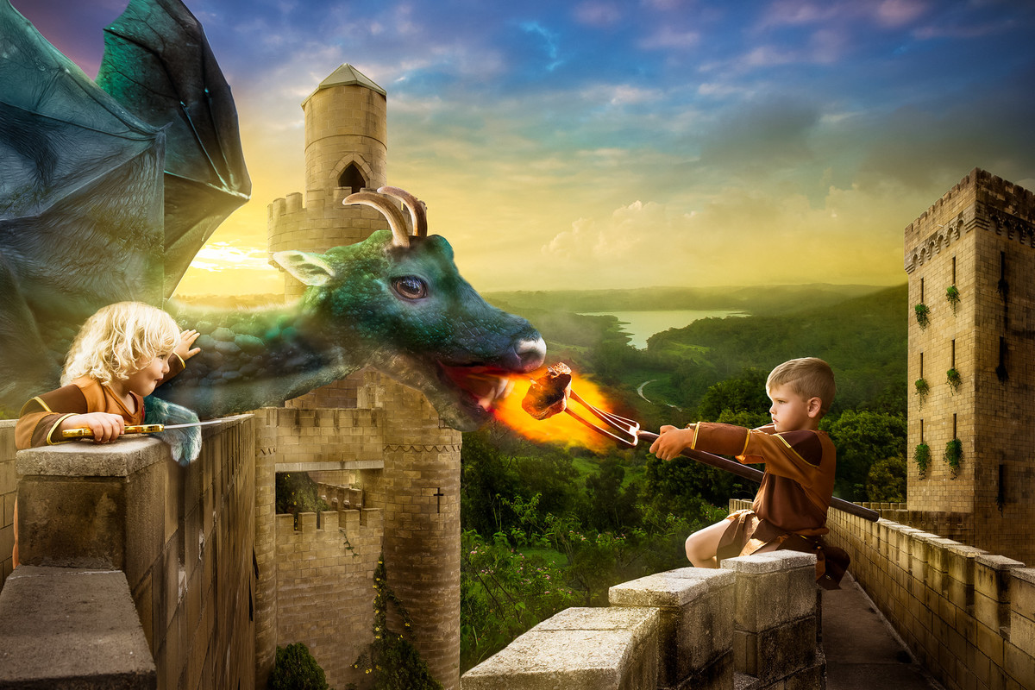
Year 2
Story starter!
- The King had known that the gift he presented to his children on their 5th birthday was dangerous. He was prepared to take the risk of letting them own a pet dragon, however. One day, the twins would rule the kingdom together, and they would need all the help they could get. No - one could deny that a dragon was a powerful ally!
- Before that day, though, the children had much work to do. They had to train their dragon!
Sentence challenge!
- Can you make a list of adjectives (describing words) to describe the dragon?
- Can you make a list of verbs (doing words) to say what the dragon is doing?
- Can you make a list of adverbs to describe how the dragon is eating? Adverbs give more detail about the verb (action) and usually end in ‘ly’. For eg slowly, carefully
- Can you now write some sentences using verbs, adverbs and at least one adjective in each sentence?

Year 1
Sentence challenge!
- Can you make a list of adjectives (describing words) to describe the dragon?
- Can you make a list of verbs (doing words) to say what the dragon is doing?
- Can you now write some sentences using the words you have collected?

