Squirrels – English
Last week we looked at the dragon. This week I would like you to answer the following questions.
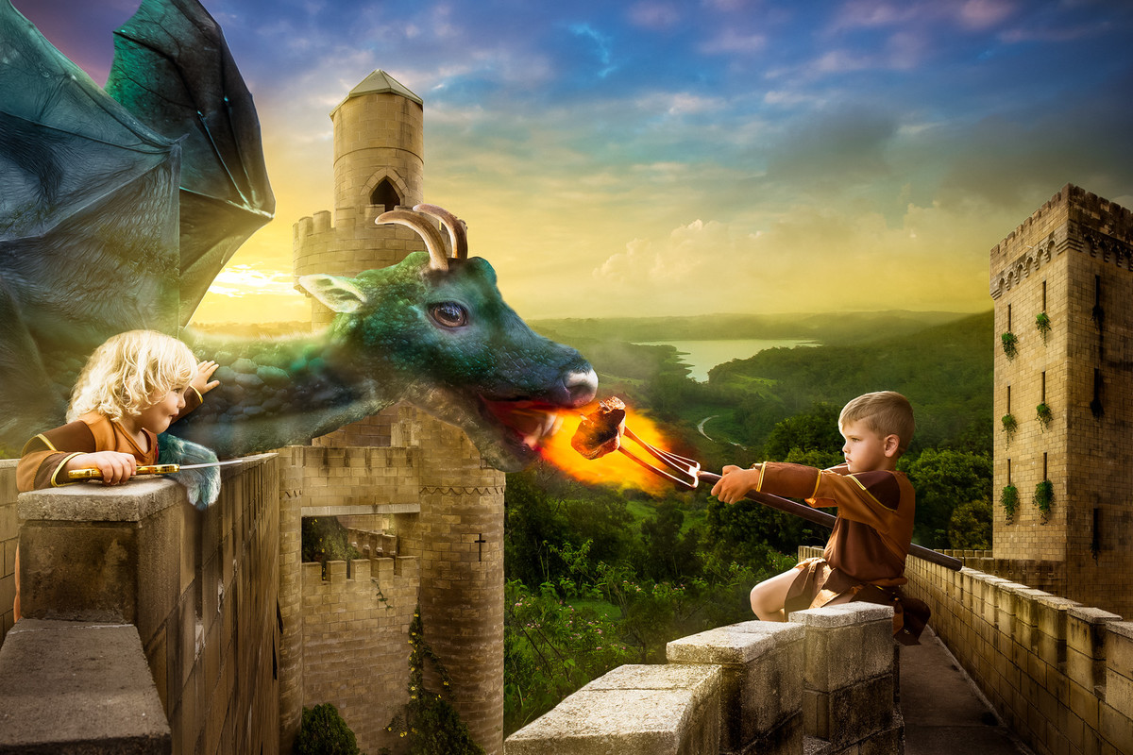
Year 2
- Why has the King given his children a dragon?
- Do you think it’s a wise decision?
- What do you think the children will try and train their dragon to do?
- Can you think of any strategies that the children might use to train their dragon?
- Where do the children live?
- Can you think of a good name for their kingdom?
- Why do you think the children will need ‘all the help they can get’ when they come to rule?
- Can you think of names for the children?
- What is the boy feeding the dragon?
- What do you think the girl is carrying?

Year 1
- What do you think the dragon is called?
- What do you think is the name of the kingdom?
- Can you think of names for the children?
- What is the boy feeding the dragon?
- Do you think the dragon is friendly? Why or why not?

