Squirrels – English
Read the story starter again:
Story starter!
The King had known that the gift he presented to his children on their 5th birthday was dangerous. He was prepared to take the risk of letting them own a pet dragon, however. One day, the twins would rule the kingdom together, and they would need all the help they could get. No - one could deny that a dragon was a powerful ally!
Before that day, though, the children had much work to do. They had to train their dragon!
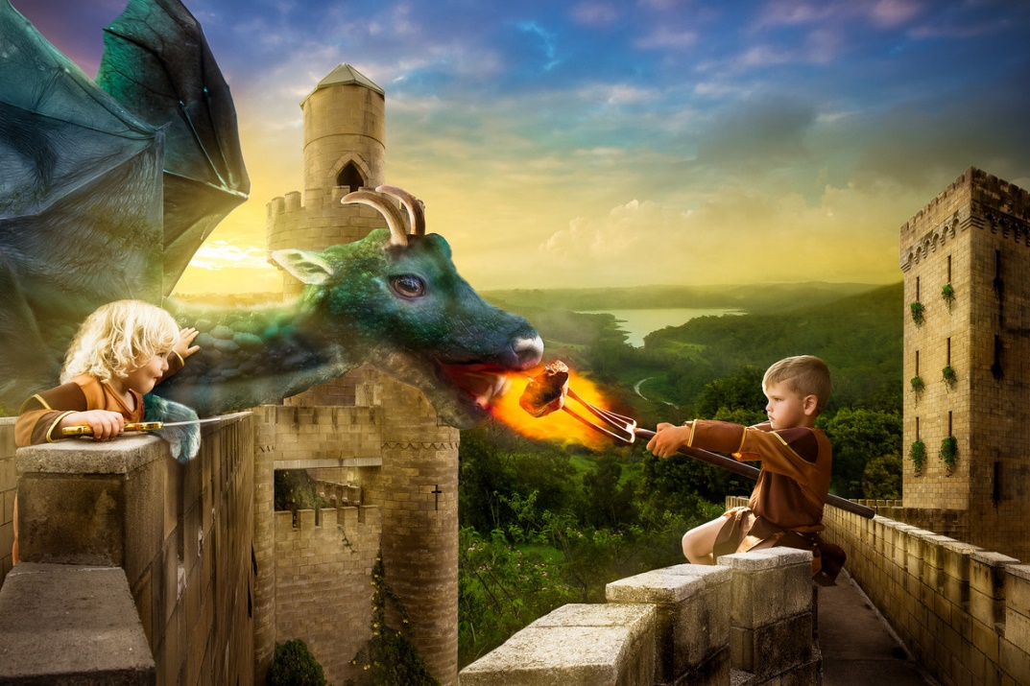
Year 1 and 2
I am curious to read more! Could you write the next paragraph for me today? Remember to use interesting sentences as this is not any ordinary story. You will need lots of imagination to capture my attention and to engage me in what’s happening.

What you need to be successful:
Wow words: incredible, vicious, prowled, sprinted, terrifying, supernatural, thrilling
Golden rules: capital letter, finger space, full stop
Interesting sentence openers:
Lurking in the dark was….
In the distance prowled the most…
I drew my weapon incredibly….

Challenge
Could you write the whole story?

