**Squirrels Maths**

**Year 1 and 2**

**Colouring Triangles**

What do you see below?  
  
  
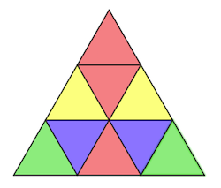    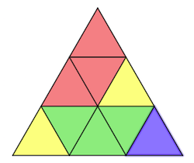   
  
What do you notice?  
What is the same and what is different about the two pictures? Write a short explanation.

Now, it is your turn to colour!  
Explore ways of colouring the black and white outline of the triangles below:

Can you make symmetrical patterns? With two colours? Three colours?  
More than three colours? (**Symmetrical patterns** are a design or **pattern** that is identical on both halves so when you fold the triangle down the middle, the two halves would be identical)  
  
I would love to see the triangles you create.  Do send them in along with your explanation of how you know the pattern is symmetrical. You may find the following sheet useful. If you can’t print the sheet, you can draw these triangles on paper. It is fun!

